This bulletin from the Cooperative Extension Plant Health Clinic (Plant Disease Clinic) is an electronic update about diseases and other problems observed in our lab each month. Input from everybody interested in plants is welcome and appreciated.

 The Plant Health Clinic now has a Facebook page:
https://www.facebook.com/UAEXPlantHealthClinic/?pnref=story

Asparagus

Asparagus is a high value crop that is both delicious and good for you. It contains vitamins A, C, E, K, and B6, as well as folate, iron, copper, calcium, protein, and fiber. Many Arkansas gardeners who grow asparagus become discouraged when their plants begin to wilt and die.

Fusarium Crown and Root Rot of Asparagus is a serious disease wherever it is found. At least four species of Fusarium have been identified as causal agents including F. oxysporum f. sp. Asparagi, F. proliferatum (moniliforme), F. redolens and F. solani. The disease primarily affects mature plantings, but can attack transplants and seedlings as well. Symptoms in the field are yellowing and stunting of plants. Affected crowns show brown areas next to healthy tissue. Eventually the entire crown becomes involved and dies. Roots have a reddish brown discoloration in the vascular area. The smallest feeder roots will be completely rotted. There are no chemical controls for Fusarium Crown and Root Rot. Excellent cultural practices are required as stress may play a role in development and severity of the disease. Proper watering practices, weed control, and fertilization are necessary for both limiting disease and good yield. There are varieties available with resistance and those should certainly be used as a first line of defense. Jersey Giant, Jersey Supreme, Jersey Knight, Millennium, and Purple Passion are all cultivars with resistance.

Asparagus Fusarium Crown and Root Rot-Fusarium sp.

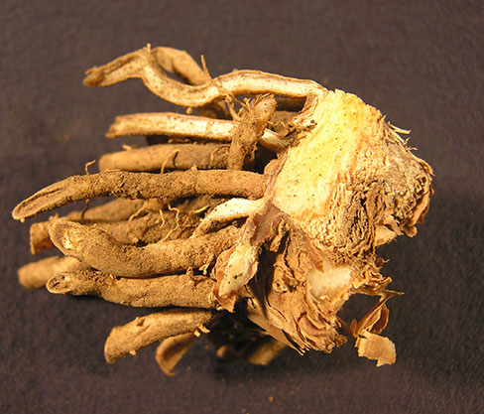
Sherrie Smith, University of Arkansas Cooperative Extension

Asparagus Fusarium Crown and Root Rot-Fusarium sp.

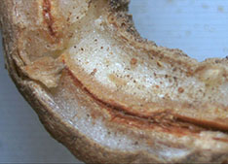
Sherrie Smith, University of Arkansas Cooperative Extension

Another common cause of wilt and death of Asparagus is Crown and Spear Rot, caused by Phytophthora megasperma. Symptoms are soft, water soaked spots on the spears slightly above, or below the soil line. The lesions expand as they age, eventually collapsing and shriveling. This collapse may cause the spear to bend like a shepherds crook. The internal tissues become discolored, turning brown to black as the crown rots. Severely rotted stems become blackened and fibrous. The extent of the damage depends on rainfall and soil drainage. Growers should avoid planting in fields with poor drainage. Ridomil Gold SL, Ultra Flourish and Aliette are labeled for control of Phytophthora in asparagus, but are not cost effective for most home gardeners.

Asparagus Phytophthora Crown and Spear Rot- Phytophthora megasperma

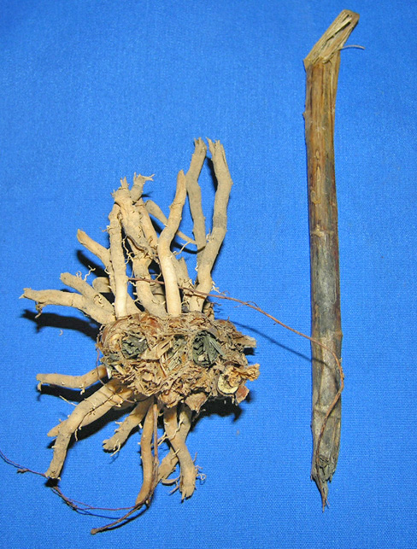
Sherrie Smith, University of Arkansas Cooperative Extension

Asparagus Phytophthora Crown and Spear Rot- Phytophthora megasperma

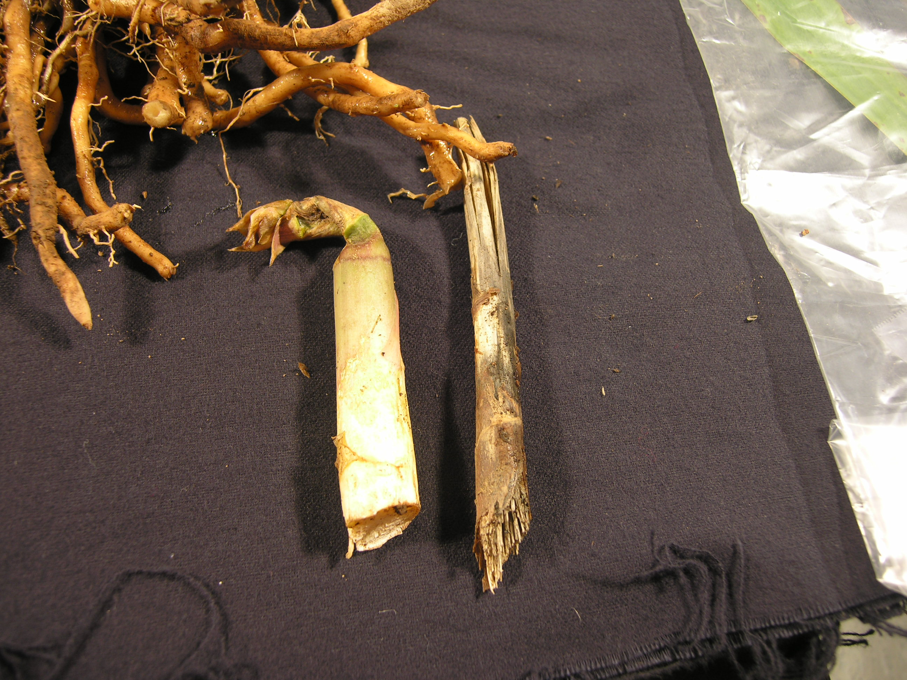
Sherrie Smith, University of Arkansas Cooperative Extension

Purple Spot, caused by the fungus Leospora herbarium (anamorph Stemphylium vesicarium) is another yield reducing disease of asparagus. Symptoms begin first on lower stems as tan to brown sunken, elliptical spots with purple edges. Small black spore producing bodies may be observed within the lesions. The spots enlarge and merge killing the stem and causing defoliation. Early defoliation can reduce next year’s crop by more than 50%. When the newly emerging spears are affected, they become unmarketable. Cool wet conditions in the spring and fall are favorable for the development of Purple Spot. Good sanitation practices are important in controlling Purple Spot as the fungus overwinters on old infected plant material. Last season’s ferny growth should be removed from the field and burned or disked under or otherwise disposed of. Fungicides containing azoxystrobin, or trifloxystrobin rotated with fungicides containing chlorothalonil are recommended as chemical controls.
Asparagus Purple Spot- Stemphylium vesicarium

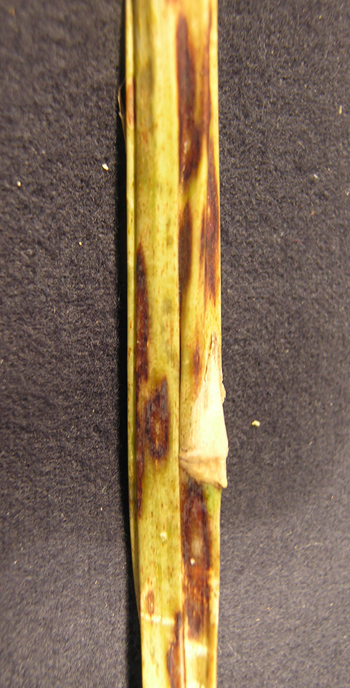
Sherrie Smith, University of Arkansas Cooperative Extension

Infestations of the Common Asparagus beetle, Crioceris asparagi, or the Spotted Asparagus beetle, Crioceris duodecimpunctata, can cause serious injury to asparagus crops. Many growers don’t realize they have an insect problem until their asparagus spears begin to develop a shepherd’s crook bending dramatically to one side. Both the larvae and adults feed on the tender growing tips of newly sprouted asparagus. Overwintered adults emerge in the spring and begin feeding, causing a brown discoloration of the tissue. Eggs are laid by adults singly or in rows of two to eight. They hatch in seven to twelve days, and the grubs begin feeding on the tender tips and foliage, and in the case of the Spotted Asparagus beetle, the berries. The larvae are yellowish-orange with black legs and head. Shoots with eggs should be cut just below ground level and removed. Gathering and destroying the berries will help control the Spotted Asparagus beetle. Insecticides containing permethrins, or carbaryl (Sevin), or Malathion give chemical control.

Asparagus Beetle Feeding Injury- Crioceris asparagi

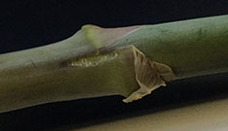
Sherrie Smith, University of Arkansas Cooperative Extension

Asparagus beetle eggs- Crioceris asparagi
Asparagus Beetle Shepherd’s Crook- Crioceris asparagi

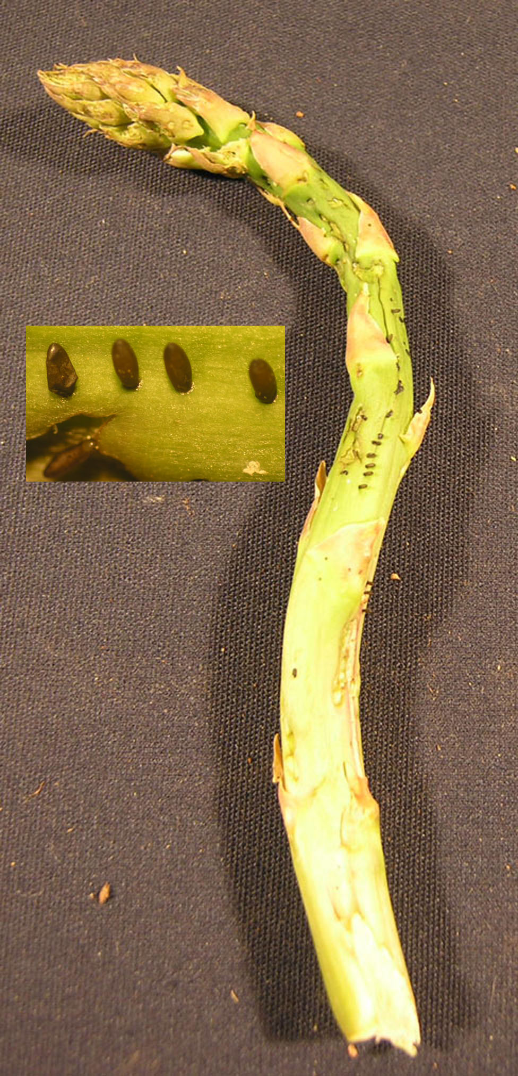
Eggs
Sherrie Smith, University of Arkansas Cooperative Extension
Common Asparagus beetle- Crioceris asparagi

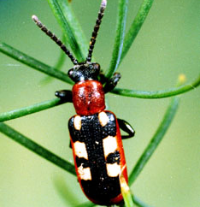
Clemson University - USDA Cooperative Extension Slide Series,, Bugwood.org.

Spotted Asparagus beetle - Crioceris duodecimpunctata

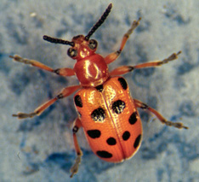
Whitney Cranshaw, Colorado State University, Bugwood.org
Asparagus beetle larva- Crioceris asparagi

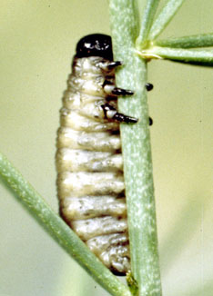
Clemson University - USDA Cooperative Extension Slide Series1, Bugwood.org.

Sherrie Smith, University of Arkansas Cooperative Extension

