This bulletin from the Cooperative Extension Plant Health Clinic (Plant Disease Clinic) is an electronic update about diseases and other problems observed in our lab each month. Input from everybody interested in plants is welcome and appreciated.

 The Plant Health Clinic now has a Facebook page:
https://www.facebook.com/UAEXPlantHealthClinic/?pnref=story

Baldcypress

Baldcypress are deciduous conifers that grows on saturated and seasonally inundated soils in the lowlands of the Southeastern and Gulf Coastal Plains of the United States. Although native to these areas of the U.S., they are offered as landscape specimens in many parts of the country. They are desired for their light, feathery foliage and orangey brown to red fall color. In cultivation Baldcypress tolerates a wide range of soils, including well drained sites where it would not grow naturally due to the inability of juvenile seedlings to compete with other vegetation. The Baldcypress Gall Midge, Taxodiomyia cupressiananassa is a small fly that lays her eggs on cypress twigs. The eggs hatch, and the larvae begin feeding on the foliage. This induces rapid gall formation that encloses the larvae, protecting them from predators. The galls are oval shaped, initially pink in color changing to white, and eventually brown as the galls age. The overwintering galls are copper brown. They fall from the tree still attached to branchlets late in the season. Gall size ranges from 20mm-3cm. The larger the gall, the more larvae it contains, with large galls containing 15 or more larvae. The larvae pupate inside the overwintering galls, and emerge in the spring as adults. The female mates and lays an average of 120 brightly colored orange, translucent eggs, in clusters of about 15 eggs each during her one to two day adult life span. Insecticides are generally not advised due to the difficulty of timing applications while adults are active. Fallen galls should be collected in autumn or in early spring before the midges become active and start laying eggs. This reduces the number of galls in a new season.
Baldcypress Gall- Taxodiomyia cupressiananassa

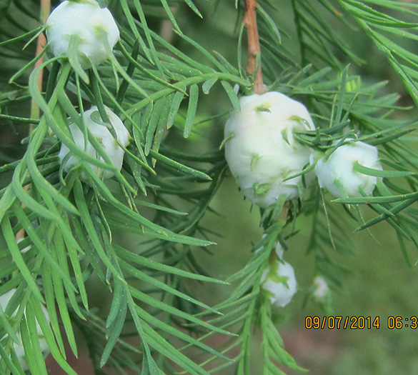
Sherrie Sanders, University of Arkansas Cooperative Extension

Baldcypress may also be attacked during the hot summer months by the Baldcypress Rust Mite, Epitrimerus taxodii. Rust mites are microscopic eriophyid mites, most active during the warm season. Symptoms are needles becoming yellowish and then brown. Serious infestations can cause the entire tree to turn a rusty brown color. The white cast skins of the mites are the easiest way to diagnose the presence of rust mites. Applications of Carbaryl (Sevin), or Abamectin (Avid), or Insecticidal soap will control the mites if good coverage is achieved. Bayer Advanced Insect Control for Trees and Shrubs is a systemic insecticide that is very effective and does not require as many applications. Baldcypress is very sensitive to horticultural oils so avoid the use of oils for mite control on Bald cypress.

Baldcypress Rust Mite damage- Epitrimerus taxodii

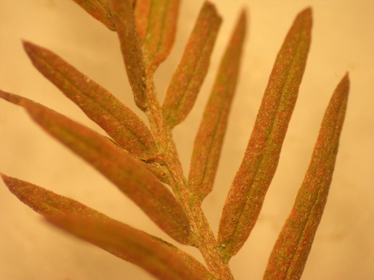
Sherrie Smith, University of Arkansas Cooperative Extension

Baldcypress Rust Mite cast skins- Epitrimerus taxodii

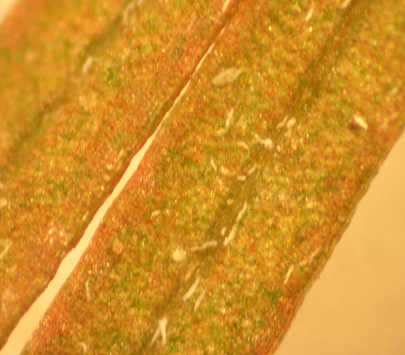
Sherrie Smith, University of Arkansas Cooperative Extension

Pumpkin

Bacterial Spot of pumpkin, caused by the bacterium Xanthomonas campestris pv. cucurbitae, can be a serious disease of pumpkins, cucumbers, gourds, and squash. Yield losses in excess of 50% have been recorded in severely infested fields. Leaf symptoms appear as small, dark, angular lesions, with the centers of the lesions becoming translucent with age. However, the most damaging symptoms appear on the fruit. Fruit lesions begin as small, slightly sunken, circular spots, 1/16 to 1/18 inch in diameter. As the lesions enlarge the cuticle and epidermis crack. Larger lesions may have a scabby appearance with tan, raised blisters. Saprophytic fungi often colonize the older lesions, giving them a pinkish-white or green color depending on the species of saprophyte involved. The unsightliness of the lesions diminishes the marketability of the fruit as well as leading to significant rot in the field and in storage. The pathogen is seedborne and can also survive in crop residue. Bacterial spot is more of a problem during high temperatures coupled with rainy weather or overhead irrigation. Inoculum is splashed onto young fruit before it develops its protective waxy cuticle. Good sanitation and crop rotation with non-cucurbit crops helps limit inoculum in the field. Only clean seed should be used. Therefore it is advisable to not save seed from a previous crop. Copper fungicides may be applied during early formation and fruit expansion to protect developing fruit. Once bacterial lesions are observed on mature fruit there is nothing to be done except to practice ruthless culling of diseased fruit.

Cucurbit Bacterial Spot - Xanthomonas campestris pv. cucurbitae

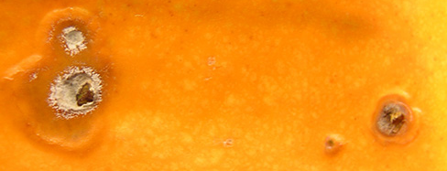
Sherrie Smith, University of Arkansas Cooperative Extension

Cucurbit Bacterial Spot with secondary fusarium infection- Xanthomonas campestris pv. cucurbitae

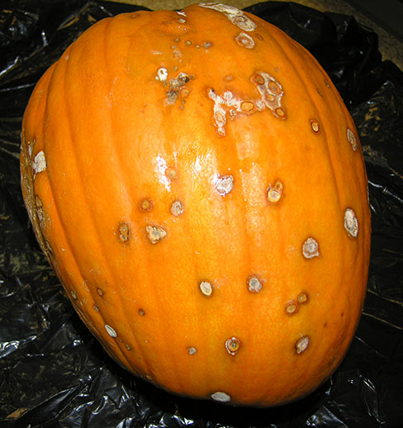
Sherrie Smith, University of Arkansas Cooperative Extension

Cucurbit Bacterial Spot scabby stage- Xanthomonas campestris pv. cucurbitae

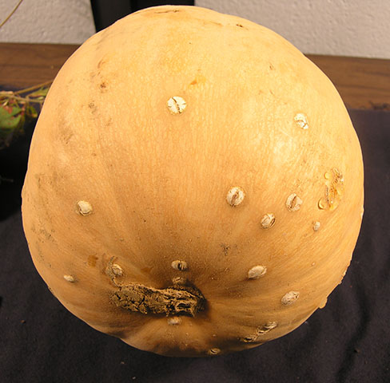
Sherrie Smith, University of Arkansas Cooperative Extension

"This work is supported by the Crop Protection and Pest Management Program [grant no. 2017-70006-27279/project accession no. 1013890] from the USDA National Institute of Food and Agriculture."
https://nifa.usda.gov/sites/default/files/resource/Powerpt_usda_nifa_horizontal_rgb_300.jpg

