This bulletin from the Cooperative Extension Plant Health Clinic (Plant Disease Clinic) is an electronic update about diseases and other problems observed in our lab each month. Input from everybody interested in plants is welcome and appreciated.

 The Plant Health Clinic now has a Facebook page:
https://www.facebook.com/UAEXPlantHealthClinic/?pnref=story

Tomato

Adult stink bugs are shield-shaped insects with piercing sucking mouthparts. They get their common name “Stink bug,” from the strong odor they emit when disturbed. Several species of stink bugs feed on tomato fruit as well as on many other vegetables, fruits, nuts, and field crops. Stink bug species in Arkansas include the Green stink bug, Acrosternum hilare (Say), the Southern green stink bug, Nezara viridula (Linnaeus), the Brown stink bug, Euschistus servus (Say) and the Rice stink bug, Oebalus pugnax (Fabricius). Stink bugs pierce tomato fruit and inject enzymes from their salivary glands to liquefy and pre-digest the plant material. Damage on green tomato fruit appears as dark pinpricks surrounded by a light discolored area. On ripe fruit the area around the feeding site usually turns yellow. If the skin of the fruit is peeled back, white spots may be observed on the flesh of the tomato. For stink bug control, homeowners may use Ortho Max Flower, Fruit, Citrus, and Vegetable Insect Control, or Bayer Advanced Insect Control, or Spectracide Insect Control, or permethrins. Scouting and handpicking can eliminate a few. Stinkbug traps are also available.

Tomato Stinkbug Damage

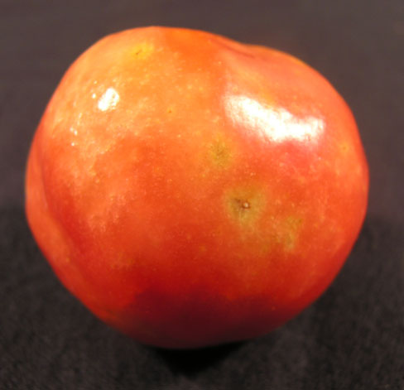
Sherrie Smith, University of Arkansas Cooperative Extension

Tomato Stinkbug Damage

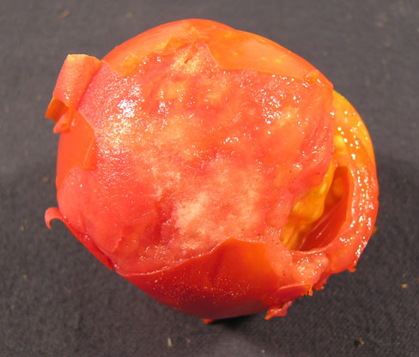
Sherrie Smith, University of Arkansas Cooperative Extension

Green Stinkbug-Acrostemum hilare

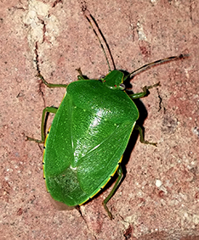
Ricky Corder, formerly University of Arkansas Cooperative Extension

Spider mites attack many species of plants, including vegetables and ornamentals. Several species of spider mites attack tomato, notably Tetranychus urticae and T. evansii. Spider mites are typically found feeding and reproducing on the undersides of leaves. They are sap feeds, feeding off the contents of individual plant cells. Their feeding activity produces a white to yellow stippling across the surface of the plant tissues that eventually takes on a bronze appearance. Leaves become dry and brown. Heavy feeding on fruit causes yellowish speckling across the surface of the fruit. Serious infestations can kill leaves and eventually the plant. In heavy infestations, small webs may be observed. It’s important to recognize the problem before leaves start dying. Commercial growers may use Agri-Mek 0.15 EC, or Brigade 2 EC, or Dicofol 4E, or Oberon 2 SC. Homeowners may use Malathion,or insecticidal soaps. Depending on the product used, applications should be made every 2 to 3 days.

Tomato Spider Mite Damage-Tetranychus sp.

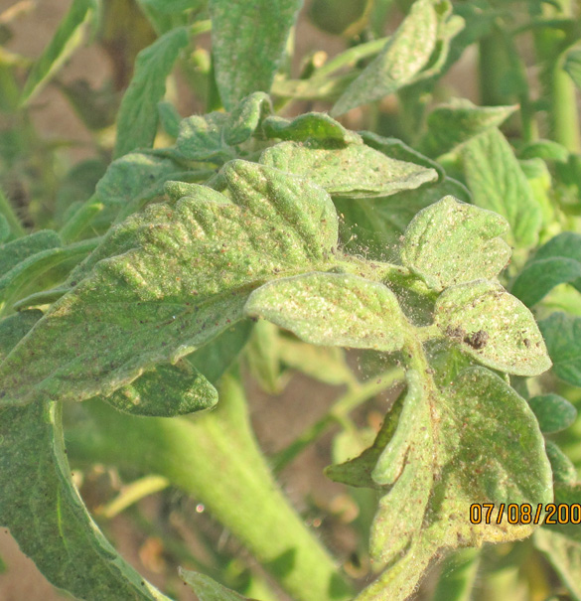

Sherrie Smith, University of Arkansas Cooperative Extension
Don Plunkett, formerly University of Arkansas Cooperative Extension

Tomato Spider Mite Damage-Tetranychus sp.

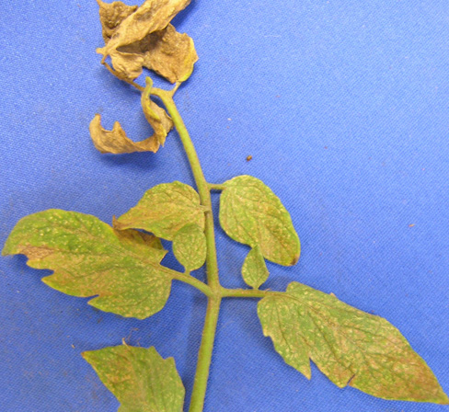
Sherrie Smith, University of Arkansas Cooperative Extension

Tomato Spider Mite Damage-Tetranychus sp.

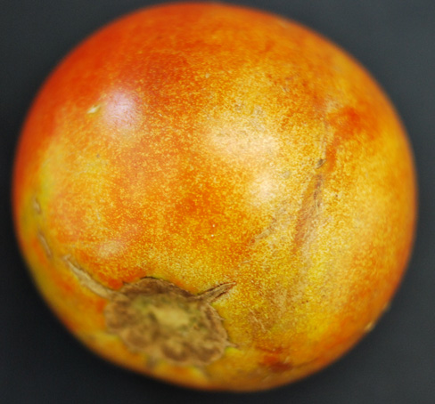
Sherrie Smith, University of Arkansas Cooperative Extension
Phlox

Tall garden phlox, (Phlox paniculata and Phlox maculata) are lovely summer blooming perennials. They are available in a range of colors from pure white, orange, blue violet, through all the pink and magenta shades. They have a long bloom period beginning in late spring to midsummer, depending on cultivar. Some varieties such as Carolina phlox Miss Lingard repeat bloom. Many have a sweet fragrance. They all make lovely long lasting cut flowers. Size ranges from 18 inches to nearly 3 feet tall. They do best in rich moist soil in full sun. Unfortunately, some cultivars are very susceptible to Powdery Mildew, caused by the fungus Erysiphe cichoracearum. Symptoms are a powdery white-grayish film on the surface of the leaves. As a rule, maculata varieties are more resistant than paniculata varieties. Nursery catalogs will often mention whether a given variety has resistance to powdery mildew. Phlox ‘David” has excellent powdery mildew resistance in a lovely white. ‘Franz Shubert’ in a lilac blue has good resistance also.

Another problem that is less commonly seen is Septoria Leaf Spot. Symptoms are dark brown to blackish spots with paler centers. Badly infected leaves may turn yellow and fall off. Septoria Leaf Spot is more often found under crowded nursery conditions with overhead irrigation than in the home garden. For both Powdery mildew and Septoria Leaf Spot, homeowners may use Fertilome Broad Spectrum Lawn and Garden Fungicide, (chlorothalonil), or Hi-Yield Vegetable, Flower, Fruit, and Ornamental Fungicide,(chlorothalonil) or Ortho Maxx Garden Disease Control, (chlorothalonil), or Ortho Disease B Gon Garden Fungicide, (chlorothalonil), or Garden Tech Daconil Fungicide,(chlorothalonil), or Bonide Fung-onil Multipurpose Fungicide, (chlorothalonil), or Spectracide Immunox Plus, (myclobutanil & permethrin), or Bonide Rose Rx Systemic Drench, (tebuconazole), or Bayer Advanced Garden-Disease Control for Roses, Flowers, Shrubs, (tebuconazole), or Bayer Advanced Garden-All-in-One Fungicide/Insecticide/Fertilizer, (tebuconazole & imidacloprid), or Fertilome 2-N-1 Systemic Fungicide,(tebuconazole & imidacloprid),or Bonide Infuse Systemic for Turf and Ornamentals, (thiophanate-methyl), or Ortho Rose and Flower Insect and Disease Control, (triticonazole & acetamiprid).
Phlox powdery Mildew- Erysiphe cichoracearum

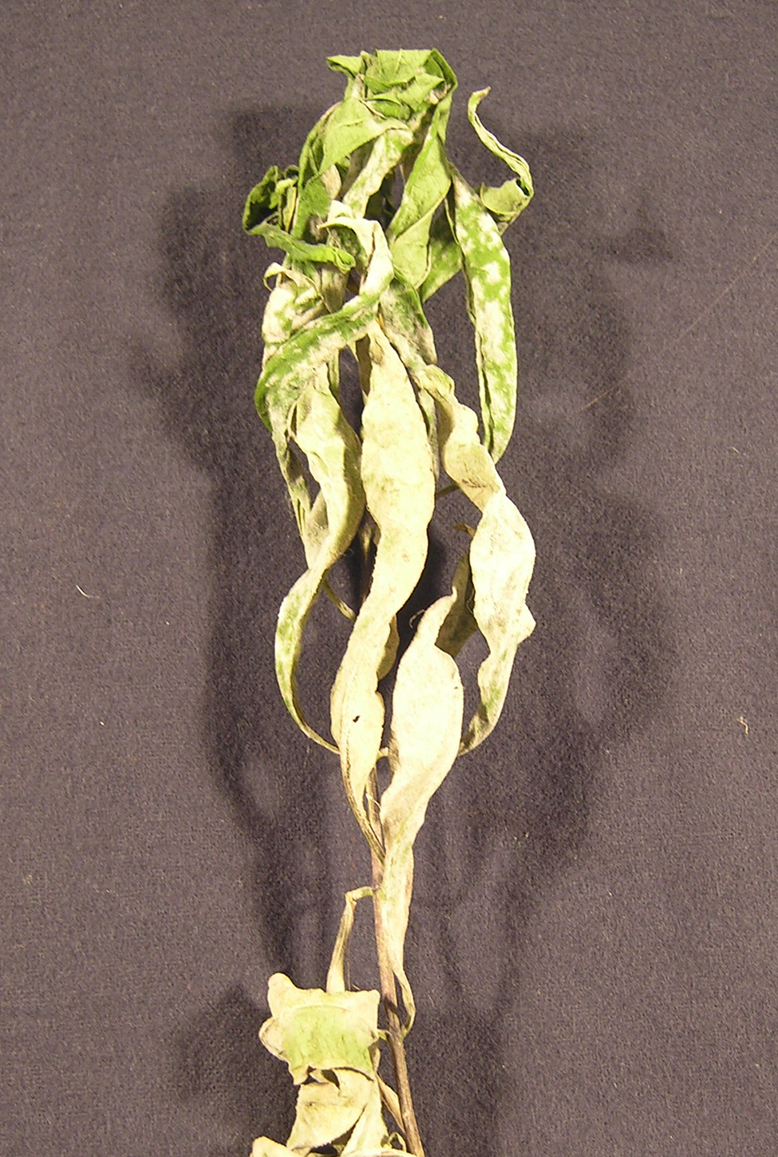
Sherrie Smith, University of Arkansas Cooperative Extension

Phlox Septoria Leaf Spot- Septoria phlogis (formerly Septoria divaricatae)

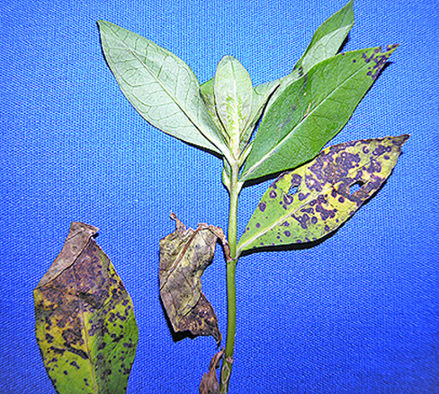
Sherrie Smith, University of Arkansas Cooperative Extension

"This work is supported by the Crop Protection and Pest Management Program [grant no. 2017-70006-27279/project accession no. 1013890] from the USDA National Institute of Food and Agriculture."
https://nifa.usda.gov/sites/default/files/resource/Powerpt_usda_nifa_horizontal_rgb_300.jpg

