This bulletin from the Cooperative Extension Plant Health Clinic (Plant Disease Clinic) is an electronic update about diseases and other problems observed in our lab each month. Input from everybody interested in plants is welcome and appreciated.

Maple

A common pest of maple in North America is the Maple Bladdergall Mite, Vasates quadripedes. Silver maple, Acer saccharinum, and Red maple, A. rubrum are both hosts. These mites are Eriophyid mites, tiny, carrot-shaped mites. They overwinter as adults under bark scales and other protected sites on the host tree where they are able to withstand winter weather conditions. Early in the spring they migrate to newly expanding leaves and begin to feed. Their feeding activity results in the formation of green or red globular growths that are about 2.5-3 mm in diameter on the upper leaf surface. These galls become noticeable during May, about the time the leaves are fully expanded. At first, these growths are green, becoming red with age. Heavily infested leaves may become distorted. Although unsightly, these mites do little real damage to the tree. An application of carbaryl or pyrethroids to the lower leaf surface when the leaves are about 1/4 expanded and again 10 days later may reduce infestations.

Maple Bladdergall Mite-Vasates quadripedes

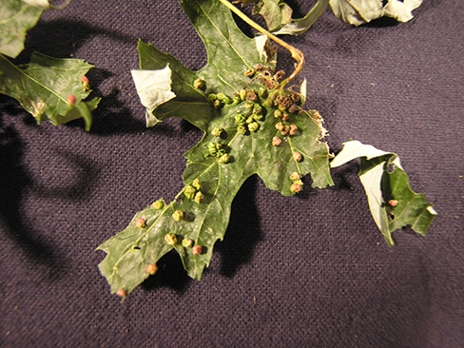
Sherrie Smith, University of Arkansas Cooperative Extension
Maple Bladdergall Mite-Vasates quadripedes

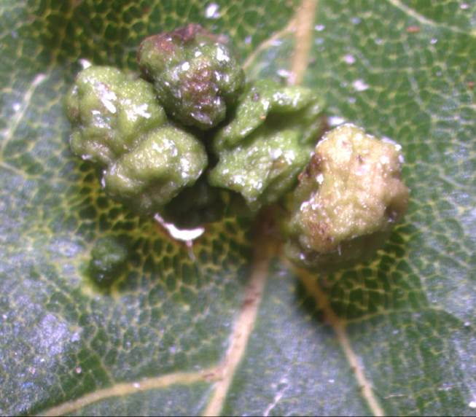
Sherrie Smith, University of Arkansas Cooperative Extension

Maple Bladdergall Mite-Vasates quadripedes

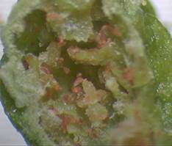
Sherrie Smith, University of Arkansas Cooperative Extension

Azalea

This is the time of year that the Clinic receives samples of azalea leaves with thickened, fleshy, distorted areas. Azalea Leaf gall, caused by Exobasidium vaccinii, affects new growth only, especially during cool, wet springs. Initially the galls are pink to white, but eventually become brown with age. Only new leaves are susceptible. Older leaves do not become infected. Azalea Leaf gall is an unattractive nuisance, but does not kill the plant. Blueberries and camellias are also susceptible to leaf galls caused by Exobasidium vaccinii. Good sanitation practices are usually enough to control Azalea Leaf Gall. Leaves with galls should be removed from the planting as soon as they appear. For badly infected plantings, start chemical control on azaleas with a history of Leaf gall at the first sign of new growth in the spring. Products containing mancozeb, or triadimefon, or myclobutanil, or chlorothalonil may be applied at bud break and at 10-14 day intervals until new leaves harden. Homeowners may use Fertilome Broad Spectrum Lawn and Garden Fungicide, (chlorothalonil), or Hi-Yield Vegetable, Flower, Fruit, and Ornamental Fungicide,(chlorothalonil) or Ortho Maxx Garden Disease Control, (chlorothalonil), or Ortho Disease B Gon Garden Fungicide, (chlorothalonil), or Garden Tech Daconil Fungicide,(chlorothalonil), or Bonide Fung-onil Multipurpose Fungicide, (chlorothalonil), or Spectracide Immunox Plus, (myclobutanil & permethrin), or Bonide Rose Rx Systemic Drench, (tebuconazole), or Bayer Advanced Garden-Disease Control for Roses, Flowers, Shrubs, (tebuconazole), or Bayer Advanced Garden-All-in-One Fungicide/Insecticide/Fertilizer, (tebuconazole & imidacloprid), or Fertilome 2-N-1 Systemic Fungicide,(tebuconazole & imidacloprid),or Bonide Infuse Systemic for Turf and Ornamentals, (thiophanate-methyl), or Ortho Rose and Flower Insect and Disease Control, (triticonazole & acetamiprid).

Azalea Leaf Gall-Exobasidium vaccinii

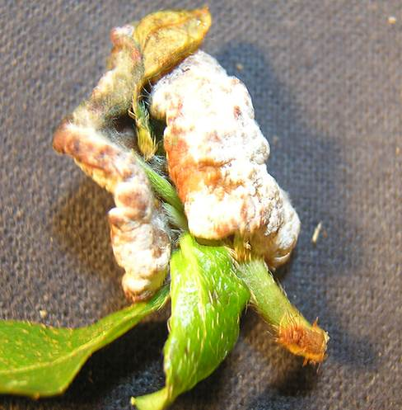
Sherrie Smith, University of Arkansas Cooperative Extension

Azalea Leaf Gall-Exobasidium vaccinii

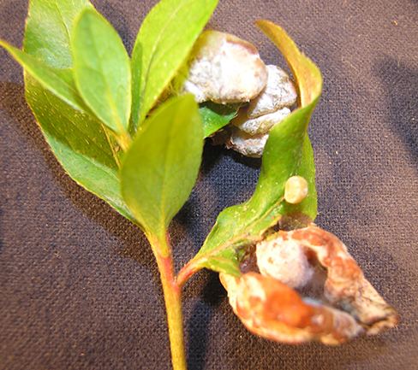
Sherrie Smith, University of Arkansas Cooperative Extension
Peach

Brown Rot is one of the most serious and pervasive fungal diseases of stone fruits. Brown rot attacks peaches, nectarines, apricots, cherries, and plums. Two species of Monilinia have been identified as causative agents in the United States; Monilinia fructicola, and M. laxa. Monilinia causes twig and blossom blight in early spring. Flowers turn brown and become a gummy mass. The infection travels down and can girdle the twig. Lens-shaped lesions can form on branches and the trunk. The infected tissue becomes covered with grayish-tan spore mass that provides secondary inoculum for additional infections. Brown rot appears on ripening to mature fruit as a rapidly growing, firm brown decay. Eventually the fruit is covered with the grayish-tan spore masses and eventually mummifies on the tree. Immature fruit that is infected remain on the tree and mummify also. Since Monilinia overwinters on mummified fruit, twigs, and cankers, sanitation is very important in the home orchard. However tedious a procedure, it is helpful to clean up as much infected tissue as possible. Homeowners may use Ortho Home Orchard Spray, or Bonide Fruit Tree Spray, or Hi-Yield Captan 50WP, or Bonide Captan 50WP, or Spectracide Immunox, or Bonide Fung-onil Multipurpose Fungicide Concentrate. Commercial growers may use Abound, or Quadris Top, or Topguard, or Pristine, or Captan, or Indar, or Eagle, or Fontelis, or Propimax, or Tilt, or Scala, or Gem, or Fontelis, Adament, or Ziram Granuflo. Timing of the first sprays is of the utmost importance. Begin at pink bud in the spring and follow label for repeat sprays.

Peach Brown Rot-Monilinia sp.

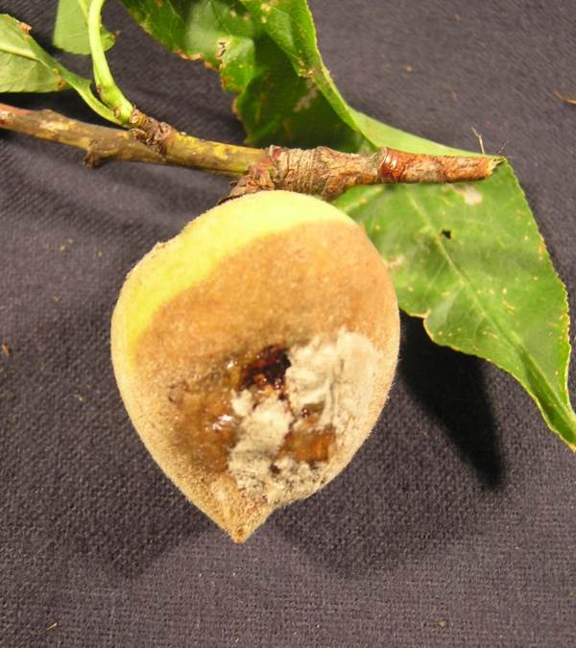
Sherrie Smith, University of Arkansas Cooperative Extension

Peach Brown Rot-Monilinia sp.
Peach Brown Rot-Monilinia sp.
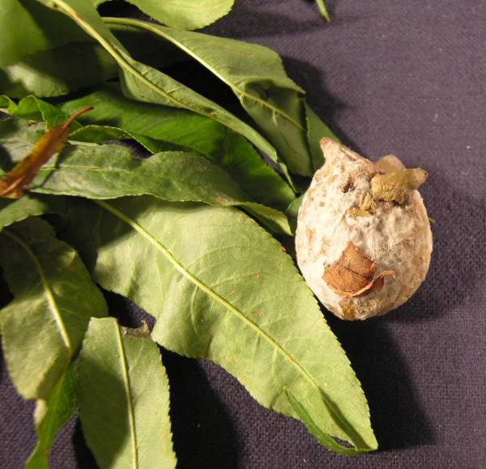
Sherrie Smith, University of Arkansas Cooperative Extension

Rose

Downy Mildew, caused by Peronospora sparsa, can cause spectacular leaf drop in susceptible cultivars when conditions are favorable for disease. To be clear, Downy Mildew is a different disease than Powdery Mildew. Downy Mildew is favored by wet, cool conditions in the spring and fall. Once temperatures rise in the summer to above 90°F, the disease becomes dormant. Symptoms may occur on leaves, stems, peduncles, calyxes, and petals. Purplish-red to dark brown angular spots develop on leaves. Large areas may be blighted, resembling a chemical burn. Leaflets may turn yellow with green islands of normal tissue. Blackish-purple lesions may appear on stems. Infected twigs may die. Good sanitation is important in reducing the amount of overwintering inoculum. Infected leaves, stems, and flowers should be removed from the planting and destroyed. Homeowners may use Bonide Mancozeb Flowable with Zinc Concentrate. Commercial growers should rotate Mancozeb with Heritage or Compass. Note that although Knockout roses are extremely resistant to Black spot, they are not resistant to Downy Mildew.

Rose Downy Mildew-Peronospora sparsa

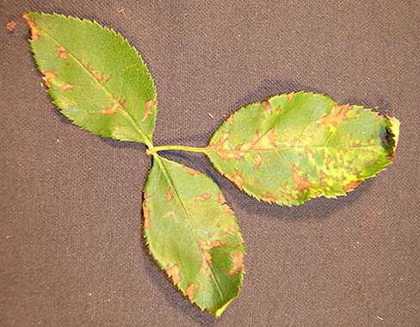
Sherrie Smith, University of Arkansas Cooperative Extension

Rose Downy Mildew Sporangiospores-Peronospora sparsa

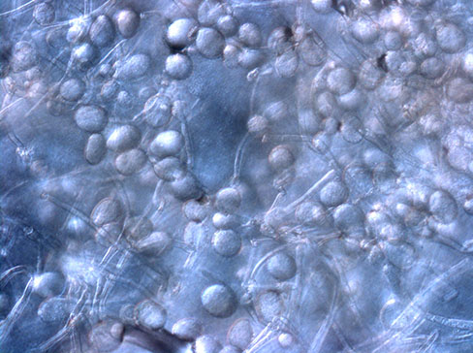
Sherrie Smith, University of Arkansas Cooperative Extension

Rose Downy Mildew-Peronospora sparsa

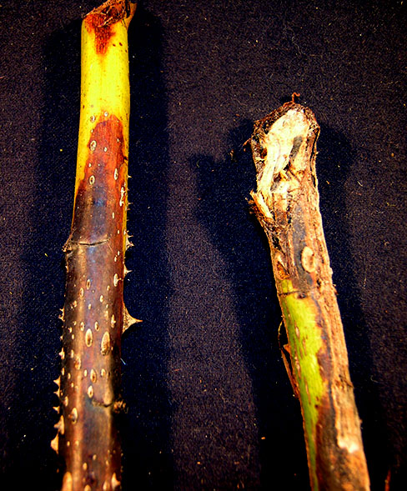
Sherrie Smith, University of Arkansas Cooperative Extension

