Pest Management News

Dr. John D. Hopkins, Associate Professor and Extension Entomologist – Coeditor
Dr. Kelly M. Loftin, Professor and Extension Entomologist – Coeditor

Contributors

Dr. Becky McPeake, Professor and Wildlife Extension Specialist
Sherrie E. Smith, Plant Pathology Instructor, Plant Health Clinic Diagnostician

Letter #6 | October 31, 2017
________________________________________________________________________________

Stopping Occasional Arthropod Invaders
John D. Hopkins

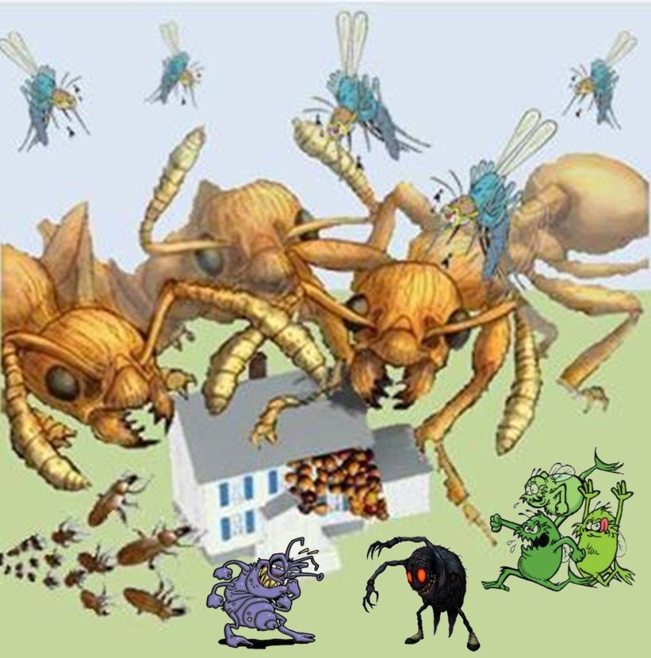
When the weather begins to change in the fall and things get cooler, arthropod pests like the multi-colored Asian lady beetle, the boxelder bug, crickets, various stinkbugs, or spiders are just some of the pest problems that homeowners may have to deal with. The first thing most people think of when trying to prevent a pest problem is WHAT INSECTICIDE DO I SPRAY? However, there are other measures that should be taken that will help prevent these pests from entering your home and may even eliminate the need for an insecticide application. Pest proofing your home is the BEST way to prevent unwanted invaders at this time or any other time of year. Your goal is to prevent pest entry and eliminate conditions that are conducive to pest infestation. Here are the ABC’s of pest proofing your home:

A. Ensure that screens on doors and windows are properly installed and maintained. If you don't have screen doors on your home, install them. Any damaged screens should be repaired or replaced. Fine mesh screening will prevent all but the tiniest insects from entering your home.

B. Doors should seal properly. If air can pass through or light can be seen through cracks around doors then insects or spiders can get in. Install tight-fitting thresholds and door sweeps to the bottoms of exterior doors and use door seals to fill the gap around the sides and top of each door.

C. Cracks in the foundation, exterior walls, and fascia boards should be repaired. Arthropod invaders use these cracks in to gain entrance to your home. Carefully inspect the exterior of your home and use your favorite caulk or silicone sealant to fill any cracks that are found.

D. Gaps around utility lines entering the home and gaps around appliance vents should be eliminated. Just like cracks in the foundation, any gaps around dryer vents, gas lines, telephone lines, etc. should be filled. If gaps are too large for caulk, spray foam products may be helpful. Also, if holes are required for ventilation (weep holes in brick veneer) copper gauze may be used to block pest entry while still allowing for air flow. Steel wool is not recommended if conditions for rust exist.

E. Varmint-proof wire or metal mesh should be installed on attic vents and crawl space vents. Rats, mice, bats, skunks, raccoons, squirrels, birds and a myriad of other creatures may make themselves at home in attics or crawl spaces if you don't install barriers to keep them out. These animals may carry fleas, mites, or create conditions favorable for other pests that may then infest your home.

F. Moisture sources should be eliminated by fixing any leaks. Most insect pests require a certain amount of humidity to survive and any source of moisture can be attractive to them. Promptly repair all plumbing leaks and remember, even condensation on pipes can drip and create conducive conditions for infestation. Make use of dehumidifiers if necessary. Basements or crawl spaces that flood during heavy rains should be equipped with a proper ventilation and drainage system.

G. Sanitation is extremely important so keep the kitchen clean. Where food and water is readily available, certain types of pests will make themselves at home. Make every effort to keep your kitchen clean. Wipe, sweep, and vacuum surfaces as required, and clean up spills immediately. Don't leave dirty dishes in the sink overnight. Toasters and microwave ovens should be cleaned out regularly and be sure to scrub down your stovetop daily. Properly dispose of food scraps and packaging.

H. Sealable containers should be used for food storage. Sealed storage containers not only prevent pest entry, but also prevent cross contamination of other food stuffs if the original product happened to be already infested. Items like cereals, grains, dry beans, rice, and other pantry items should be disposed of immediately upon first sign of infestation. Non-perishable items should be stored in air tight containers while perishables should be stored under refrigeration or frozen.

I. Eliminate clutter. Cluttered home environments provide easily accessible sites for pests to hide and harbor. Dirty laundry should be kept in clothes hampers and laundered promptly. Floors should be kept clear of belongings and items should be properly put away when no longer in use (preferably in sealable plastic storage containers. Recyclable items should be rinsed and recycled promptly. Beverage cans and bottles, milk jugs, pet food cans, etc. will all attract insects if they are not rinsed out thoroughly.

J. Clean up after your pets. Some pests like dry pet food so store your pet’s food in an air tight container. Do not leave extra pet food exposed and accessible except at feeding time and clean your pet's food dishes regularly. Other pests like flies are attracted to pet waste so clean your cat's litter box daily. Also, wash pet bedding on a regular basis.

K. Frequent removal of household garbage is a necessity. Even before you can smell it, it is attractive to pests so remove household garbage often. Line waste bins with plastic garbage bags and secure the bags tightly before taking them to outdoor garbage containers. Outdoor containers should not be located near entryways and regular scheduled pick up and removal should be arranged.

L. Clean trash bins as needed. Sometimes plastic liners or garbage bags tear and spills occur inside garbage cans. At least several times a year, clean the inside of garbage containers with soap and water or a mild bleach solution to eliminate smells and sticky substances that may attract pests. As before, outdoor garbage containers should not be kept close to the house.

M. Do not allow trees and shrubs to contact the house. Trees and shrubs in contact with the roof or outside walls of your home can serve as a bridge to allow pests to gain access to your home. Keep shrubs and tree branches pruned away from the home.

If the above listed maintenance and sanitation guidelines are carried out, pests will be discouraged or prevented from invading in the first place.

However, if nuisance pests do get inside:

In large numbers,
- They can be vacuumed up and the vacuum bag can be discarded outside.
- Line vacuum hose with a stocking and insects will be conveniently bagged.
- NO INSECTICIDE RECOMMENDED! If an insecticide is used, many insects will die in inaccessible places making clean up impossible and these dead insects will serve as a food source for other pest insects like dermestid beetles.

In low numbers or individually
- Pests can be swept up and removed, or
- Treated with an over the counter aerosol insecticide and removed.
- Over the counter residual insecticides labeled for crack & crevice and/or surface treatment may also provide relief (Low numbers only)

The use of residual insecticides labeled for perimeter application can also help provide a barrier to prevent nuisance insect pest/spider entry.

Pest proofing or preventing nuisance pests from gaining entry in the first place is the BEST strategy for stopping problem pests from invading your home whether it is in the fall or any other time of year.

You should realize that achieving a totally arthropod free home is not practical. Entomologists from North Carolina State University have found that we share our homes with more than 500 different kinds of arthropods (insects, spiders, mites, and others). Click on the link below for some interesting information from “Entomology Today,” an online publication from the Entomological Society of America.

https://entomologytoday.org/2016/01/19/researchers-find-hundreds-of-arthropod-species-in-u-s-homes/

Fall and Winter Pests of Livestock
Kelly M. Loftin

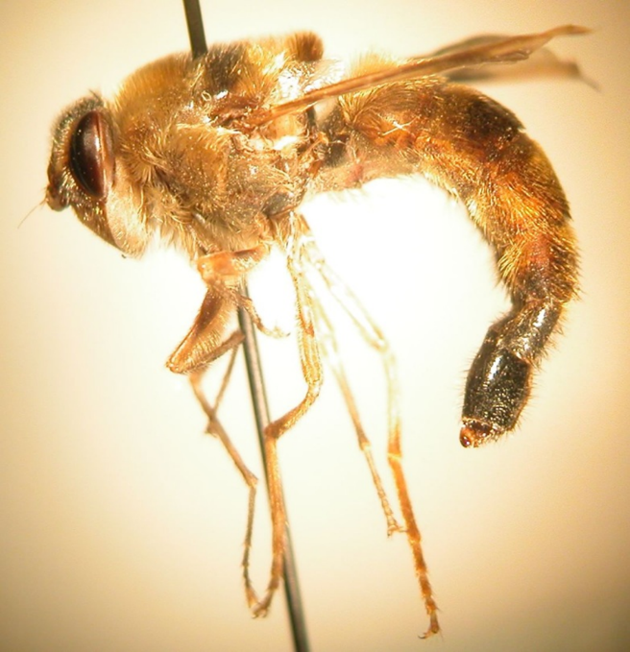
Figure 1. Adult horse bot fly, Gasterophilus intestinalis (DeGeer). (Photo by Kelly M. Loftin)
With this being the last issue of Pest Management News for 2017, I thought it would be worth mentioning potential pests concerns that could become a problem before our newsletter resumes next spring. A little bit of knowledge and planning now can prevent pest problems that we may face in the upcoming winter and spring.

Fall Treatment for Horse Bots
Some areas of the state have received at least one or two killing frosts. This signals the best time to treat our horses for bots. Even those that diligently remove bot eggs throughout the summer and fall should treat their equine companions for horse bots. Although the adults are free living and do no direct harm to horses, their immature stages (larvae) can cause damage to the stomach lining which can lead to major health issues including colic.

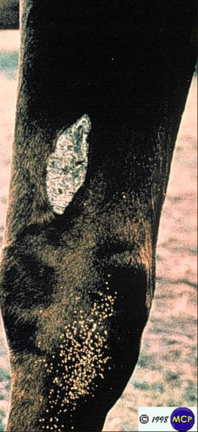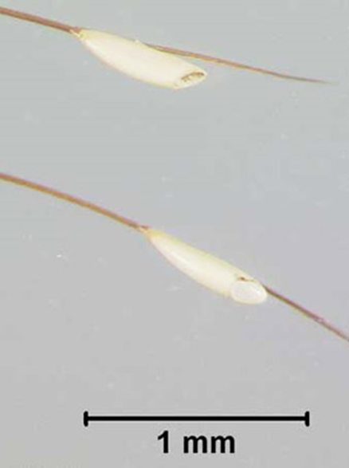
Figure 2 a. & b. Eggs of the bot fly, Gasterophilus intestinalis (DeGeer), deposited on the hairs of a horse’s foreleg. (a. Marcelo de Campos Pereira, http://www.icb.usp.br/~marcelcp/ b. University of Florida)
Horse Bot Flies (Family Gasterophilidae). Horse bot flies are in the family Gasterophilidae. The larval forms are important internal parasites of equines. The three species considered important in the U.S. are: Gasterophilus intestinalis (DeGeer), the horse bot fly; Gasterophilus nasalis (L.), the throat bot; and Gasterophilus haemorrhoidalis (L.), the nose bot. Adults resemble bees in that they are about the same size and hairy-bodied (Figure 1). Adult bot flies are short-lived, possess non-functional mouthparts thus do not feed. Adult activity begins in warm weather and ceases at the first frost.

Adult female bot flies attach eggs to the hairs of the host’s body similar to lice (Figure 2). The site of egg attachment is specific to the bot fly species. Horse bot flies attach eggs on the forelegs between the knee and hock; throat bot flies attach eggs under the jaw; and the nose bot flies attach eggs to the upper lip. Horse and throat bot fly eggs are stalkless; and nose bot fly eggs are stalked. For the horse bot fly, egg hatching is stimulated by moisture and friction from the animal’s licking. Larvae gain access to the host’s mouth by this licking, and burrow into the tongue or gums. They remain there for about a month then pass to the stomach attaching to its mucous membrane where they remain for about 9 months (Figure 3). In the spring larvae (Figure 4) detach from the stomach and are passed with feces and pupate (Figure 5) outside their host. Adults
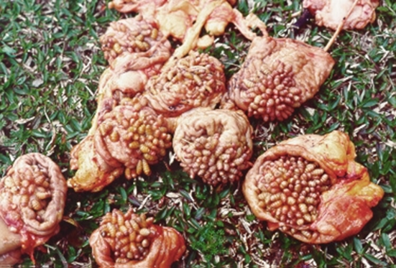
Figure 3. Bot fly larvae, Gasterophilus nasalis (L.), attached to the pyloric region of horse stomachs. (Marcelo de Campos Pereira, http://www.icb.usp.br/~marcelcp/)
emerge from pupae in about a month to 6 weeks. Horse bot flies may cause significant damage to the stomach lining and possibly stomach rupture or colic if the passageway between the stomach and small intestine becomes blocked. The life cycle of the throat and nose bot flies are similar to the horse bot fly, except mature nose bot fly larvae attach to the rectum near the anus; and the mature throat bot fly larvae attach in the duodenum (first section of small intestine) near the pylorus.

Chemical control of bot flies is aimed at the parasitic stage within the horse. Avermectin formulations containing products such as ivermectin or moxidectin are available for bot fly control in equines. These products are relatively easy to use, fall treatments should be administered after fly activity ceases (generally after the second killing frost). The “Insecticide Recommendations for Arkansas - 2017” (MP 144 http://www.uaex.edu/Other_Areas/publications/PDF/MP144/MP-144.asp) provides a listing of products available for controlling bots in equines. “Arthropods Pests of Equines” (MP 484 http://www.uaex.edu/Other_Areas/publications/PDF/MP484.pdf ) provides biology and control information on major arthropod pests of equines including horse bots. “Livestock Health Series: Internal Parasites of the Horse” (FSA 3096 http://www.uaex.edu/Other_Areas/publications/PDF/FSA-3096.pdf ) is available for more information on other internal parasites of equines including bots.

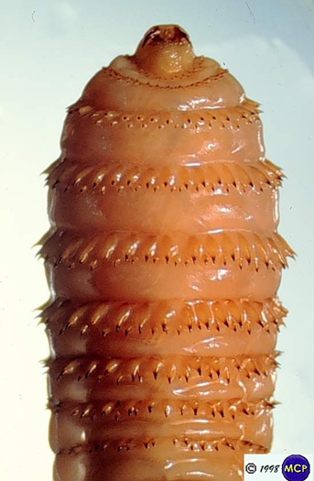 |  | 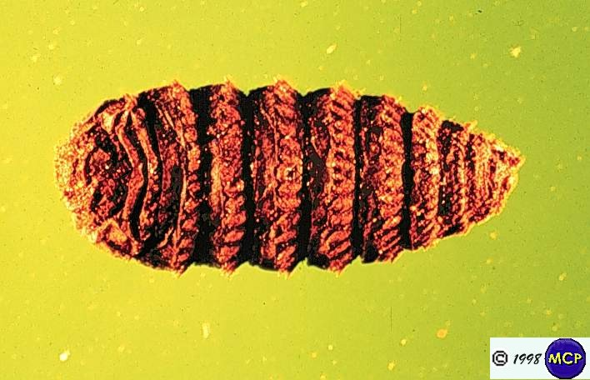
Figure 4. Bot fly larva, Gasterophilus intestinalis (DeGeer). (Marcelo de Campos Pereira, http://www.icb.usp.br/~marcelcp/) |  | Figure 5. Pupa of bot fly, Gasterophilus nasalis (L.) (Marcelo de Campos Pereira, http://www.icb.usp.br/~marcelcp/)
Non-chemical bot fly control is aimed at the eggs. Equine owners can frequently sponge the horse with warm water or to stimulate hatching of bot fly eggs. New hatched bot fly larvae quickly die especially if done on a cool day. For the horse bot fly, concentrate efforts on the animal’s legs between the hock and knee. Also, applying insecticidal washes to egg laying sites can reduce the number of larvae ingested by the animal. Bot combs or pumice bot stones can also be used to scrape away the eggs. These remedies should reduce the number of bot fly larvae ingested by the animal, but will not control any larvae that were unaffected and ingested. Because of the seriousness of bot fly infestations, treatment with a boticide to control the parasitic stages is recommended.

Very rarely, horse bots fly can cause ocular myiasis in humans. Ocular myiasis is an invasion of the eye by first stage larvae. These cases are rare and can occur in individuals handling horses that have bot fly eggs on their hair. On these rare occasions, bot fly larvae will enter the eye possibly as a result of rubbing their eyes. In other rare instances, hatched larvae enter the human skin causing cutaneous myiasis which can result in visible, inflamed tracks, irritation and itching from the larva’s burrowing. People working with horses during bot fly season should not rub eyes after combing or washing animals and thoroughly wash their hands.

Lice
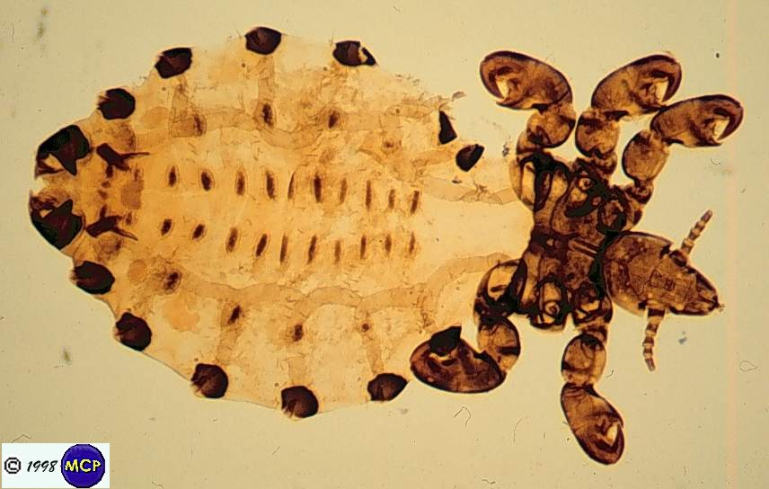
Figure 1. Sucking louse, Haematopinus sp. (Marcelo de Campos Pereira, http://www.icb.usp.br/~marcelcp/)
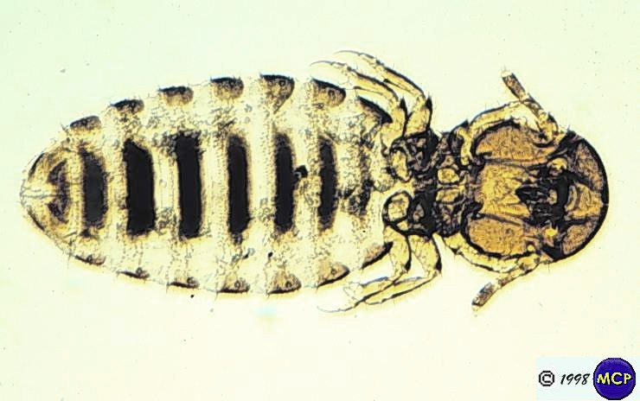
Figure 2. Horse Biting Louse, Bovicola equi (Denny). (Marcelo de Campos Pereira, http://www.icb.usp.br/~marcelcp/)

Cattle, goat, sheep and horse owners need to at least think about lice on their livestock this winter. In many cases, the potential for severe direct economic losses in cattle caused by biting or sucking lice is fairly low. However, heavy infestations add to the stress of cold weather, shipping, poor nutrition and internal parasite load. Lice are generally most abundant on animals during the period of greatest winter stress and continue through early spring.

Why are lice a winter pest? Generally, lice do not survive well in the summer because hot temperatures are lethal to the insect. However, a small percentage of animals may serve as chronically infested “reservoir” animals. A few lice on the reservoir animals survive on cooler areas of the body such as the ear tips. As temperatures cool, louse abundance increase resulting in the movement onto louse-free animals. Crowed conditions that often occur at winter feed troughs exasperate this spread.

Lice are small (¹⁄10 to ¹⁄8 inch), wingless, species-specific external parasites of livestock and poultry. Two species occasionally infest equines: the horse sucking louse (Haematopinus asini) (Figure 1) and the horse biting louse (Bovicola equi) (Figure 2). In cattle, one species of biting lice, the cattle biting louse (Bovicola bovis) and three species of sucking lice; the shortnosed cattle louse (Haematopinus eurysternus), the longnosed cattle louse (Linognathus vitula), cattle tail louse (Haematopinus quadriptusus) and the little blue cattle louse (Solenoptes capillatus) occur. Sucking lice pierce the skin and suck blood while the biting lice move about on the animal chewing hairs, skin and secretions. Both types of lice are problems during the winter and early spring but as mentioned earlier reproduce year-round at least on some animals. Lice are spread from animal to animal by direct contact such as shipping or feeding. Animals infested with lice will have an unkempt coat, scaly skin and possibly raw areas on the skin.

Infested animals will scratch and rub to relieve the itching caused by lice. Often in heavy infestations, clumps of hair will fall off. Weight loss or reduced weight gain can occur with heavy louse infestations.

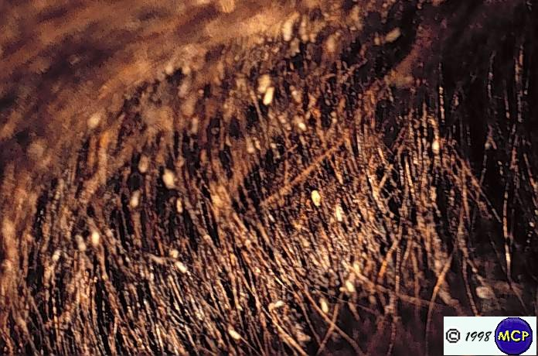
Figure 3. Louse eggs (nits) attached to horse hairs. (Marcelo de Campos Pereira, http://www.icb.usp.br/~marcelcp/)
Lice can produce multiple generations per year, thus allowing numbers to become high if uncontrolled. All louse stages (egg, nymph and adult) are found on the animal. Adult female lice glue eggs (called nits) to hairs (Figure 3), eggs hatch into nymphs in about 10 to 15 days, and after three molts, nymphs become adults. It requires about 1 month for an egg to develop into an adult.

In cattle, light louse infestations are easily overlooked. Heavier infestations are easier to recognize by animals’ rubbing and loss of hair. A lice population on cattle can be estimated by examining five one inch square areas on the face, face, dewlap, neck, back and base of the tail. Lice populations on cattle are usually categorized as very slight (less than 5 per square inch), slight (5-10 per square inch), moderate (10-20 per square inch), severe (20-50 per square inch) and very severe (over 50 per square inch).

Louse infestations are identified more quickly in horses because they are routinely groomed. Horses infested with lice will have an unkempt coat, scaly skin and possibly raw areas on the skin. Infested animals will scratch and rub to relieve the itching caused by lice. Weight loss or reduced weight gain can occur with heavy louse infestations.

Good nutrition that includes a high energy diet usually reduces the negative effects of lice infestations on livestock and is the foundation of a louse control program. Sufficient nutrition will allow the animal to better deal with blood loss and irritation. Another very important component of lice prevention is to assume that all purchased or “new” animals are infested. With this said, new animals should be isolated from the rest of the herd until a full course of louse treatment is completed.

Insecticides used for louse control are divided into two major groups; systemic products (includes some synthetic organophosphate insecticides and endectocides) and non-systemic products (primarily pyrethroids). For winter treatment of lice on cattle, selection of the right insecticide is crucial. Winter applications of endectocides containing doramectin, ivermectin, moxidectin; and systemic organophosphate insecticides such as phosmet may trigger an adverse host-parasite reaction if cattle grub larvae are in a critical stage of migration in the cattle. When lice infestations are detected during the winter months in cattle that were not previously treated for cattle grubs before Oct. 15, non-systemic products containing permethrin/diflubenzuron, cyfluthrin, permethrin, zeta-cypermethrin, gamma-cyhalothrin, and lambda-cyhalothrin are recommended. Also remember that products registered for use on beef cattle may or may not be approved for use on lactating dairy cattle so consult the label before purchase. In horses, synthetic pyrethroids such as permethrin and organophosphate insecticides such as coumaphos may be used to control louse infestations. ). Consult the animal section of the “Insecticide Recommendations for Arkansas - 2017” (MP 144 http://www.uaex.edu/Other_Areas/publications/PDF/MP144/MP-144.asp) for a listing of insecticides available for louse control.

Minimize Hay Wastage
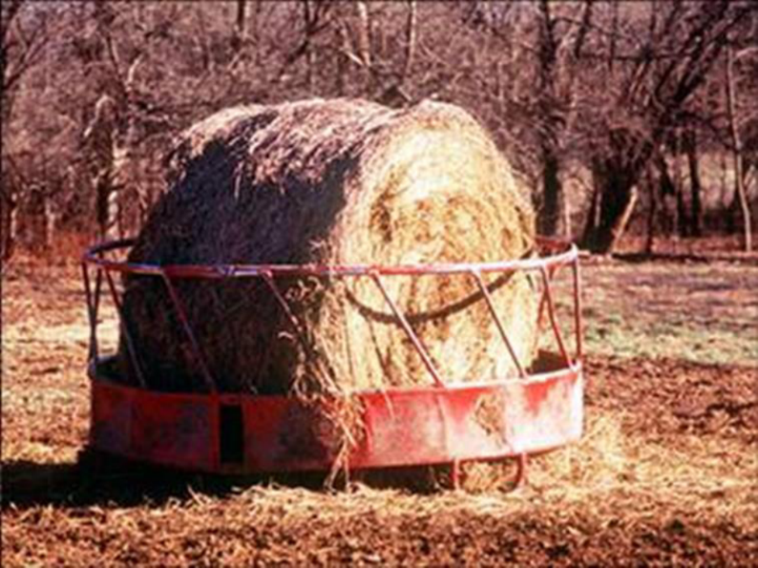
A typical stable fly breeding site – hay ring feeder. (University of Missouri Extension Service).
With winter just around the corner, we need to remember to minimize hay wastage now to prevent stable fly problems next year. Moisture, rotting hay, livestock manure and warm temperatures are the ingredients necessary for a healthy stable fly population. All these ingredients come together in areas where hay was wasted.

Practices to avoid a buildup of stable fly breeding material.

1. Modify hay feeding techniques to prevent a stable fly problem.
a. Unroll hay (in large round bales) in a different location for each feeding.
b. Distribute “flakes” of small hay bales in different locations in the pasture
c. Feed hay only in well drained areas.
d. Do not feed more than the animals will clean up during a single feeding.
2. Clean up wasted hay around hay rings before stable flies become a problem.
3. If you cannot clean up around a hay ring, run a farm implement (disk, etc.) through the area. This will kill some stable fly larvae and pupae and dry out the breeding material to inhibit larval development.

Should We Feed Aquatic Wild Birds?
Becky McPeake

“Aquatic wild birds” are non-domestic birds that live in or near lakes, ponds, swamps, and rivers. This includes ducks, geese, herons, and egrets. Many types of problems can occur from feeding aquatic wild birds:
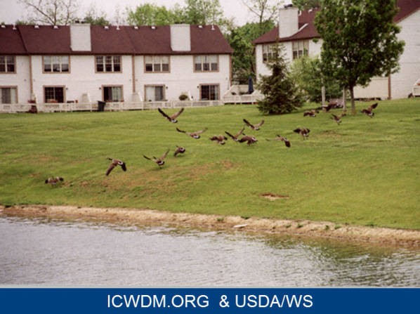
- increased spread of disease;
- degradation of water quality from bird feces;
- malnutrition from eating foods with low or no nutritional value;
- injuries from swallowing non-food items;
- behavioral problems when birds lose their fear of humans and become aggressive; and
- becoming dependent on people for food and unable to forage independently or teach their young proper foraging techniques to feed themselves.

Feeding aquatic birds concentrates them in one location, which increases the chance of disease being passed from bird to bird. Examples are avian pox and avian botulism. Avian influenza occurs naturally among wild aquatic birds, and domestic birds should be protected from exposure. It can be highly contagious particularly to poultry resulting in mortality. Avian flu viruses normally do not infect humans, however occasionally humans do get avian flu.

Large amounts of droppings where birds are fed can increase bacterial counts of E. coli on sidewalks, in parks, and in water systems. In 2017, about 20 swimming beaches were closed due to high E. coli counts in the water, presumably from bird droppings. The Arkansas Health Department lists resident Canada goose populations as a contributor with campers feeding geese worsening the situation. Bird droppings can also increase the amount of nutrients in a pond leading to excessive algae growth. Histoplasmosis is a flu-like respiratory illness in humans associated with a fungus which grows in soil containing bird droppings.

Bread and other processed foods are unhealthy for aquatic birds to consume. Reliance on such foods may result in malnutrition. The balance of fiber, fats, micronutrients, carbohydrates and proteins in a bird’s natural diet is radically different from a scavenged diet of human food. Birds can choke on large pieces of bread or other objects. Wild birds which are fed frequently become habituated to taking handouts and often develop a repetitive behavior of swallowing anything that is thrown to them.

Birds which lose their fear of people can become aggressive, particularly during the nesting season. Young birds fed on a diet of human food become unable to fend for themselves and unable to teach their young foraging habits. Some migratory species may alter their migration patterns if food is provided year-round.

Primary sources for this article is “Why Shouldn’t We Feed Water Birds?” by the University of Florida IFAS Extension and the Arkansas Department of Health website.

A Gall Forming Bacterial Disease of Loropetalum
Sherrie E. Smith

Loropetalum are cold hardy in USDA zones 7-10 and are easy to grow, versatile shrubs. They prefer some afternoon shade and moist, well-drained, acidic soil with plenty of organic matter. They are very tolerant of drought conditions once established. The bacterium, Pseudomonas savastanoi, causes galls on oleander, olive, ash, privet, and forsythia as well as loropetalum. Symptoms are wilting, dead shoots, stems, and plant death. During wet weather bacteria may ooze from the galls. The bacterium is believed to enter plant tissue through wounds caused by pruning, as well as through weather events such as hail and freeze injury. A few galls do not seriously impact the plant, but unfortunately the galls can become numerous rather quickly, Signs of the disease are dark colored, rough textured galls or knots on twigs and branches. The galls begin as small hardly noticeable rough spots, but can enlarge to cover 6 or more inches of the stem. Bacterial gall is a very difficult disease to control. Removal of all galled branches may help slow the disease. Remove galls several inches below the damage, dipping pruners in 10% bleach solution between cuts. Prune only during dry weather. The application of copper fungicides/bactericides after pruning may also be beneficial. An alternative is to remove the plant entirely.

Galls on Loropetalum caused by the bacterium, Pseudomonas savastanoi
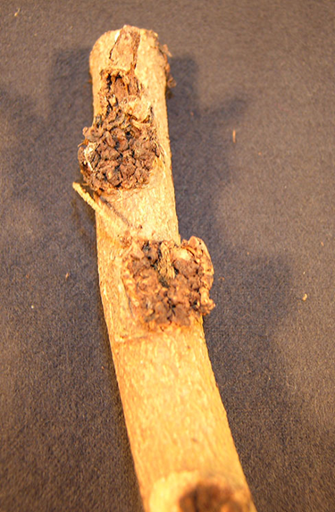 | 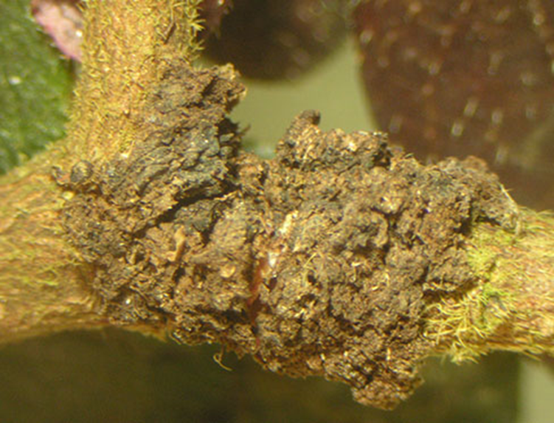
Photos by Sherrie Smith

To The Readers
Please offer any suggestions for Urban or Livestock Integrated Pest Management topics (insect pests, plant diseases, weed problems, wildlife control problems) that you would like to see – OR – feel free to submit an article that you have prepared. Kelly and I will be glad to include it (subject to editing). Send feedback to jhopkins@uaex.edu or kloftin@uaex.edu

