Pest Management News

Dr. John D. Hopkins, Associate Professor and Extension Entomologist – Coeditor
Dr. Kelly M. Loftin, Professor and Extension Entomologist – Coeditor

Contributors

Dr. Becky McPeake, Professor and Wildlife Extension Specialist
Dr. Bob Scott, Professor and Extension Weed Scientist
Sherrie E. Smith, Plant Pathology Instructor, Plant Health Clinic Diagnostician
Jon Zawislak, Entomology Instructor, Apiculture Specialist
Hank Chaney, Area ANR Specialist
Steven Stone, CEA-Staff Chair, Lincoln County
Dr. Gus Lorenz, Assoc. Dept. Head and Extension Entomologist

Letter #3 | July 31, 2017
________________________________________________________________________________

Ground Bees in the Landscape
John D. Hopkins

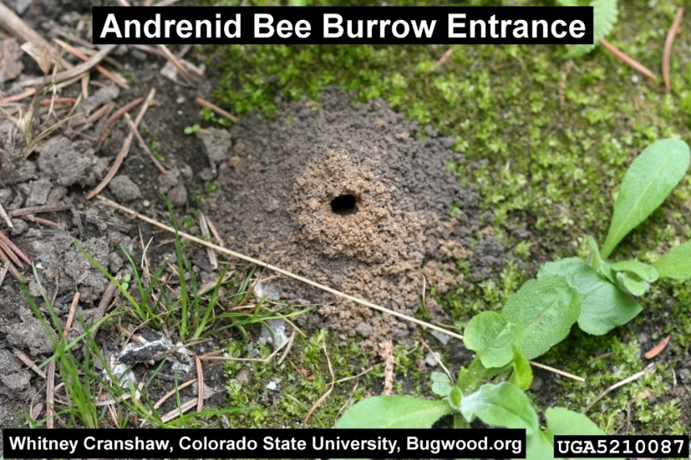
Should you be concerned about bees digging burrows in your yard? Ground bees become active in early spring. These bees dig nests in the ground, often in bare patches of the lawn or garden. If you find mounds of soil, similar to anthills but with larger openings, these may be ground bee nests. Watch for bees flying low over the ground and entering their burrows. Ground bees perform an important role as pollinators and, as such, are consider beneficial insects.

Ground-nesting bees include sweat bees in the family Halictidae, mining bees in the family Andrenidae, and digger bees in the family Anthophoridae. Females excavate a nest in dry soil, and mound the loose soil around the nest entrance. She provisions the nest with pollen and nectar for her offspring.
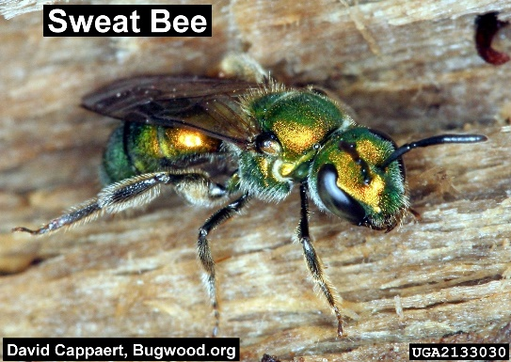 | 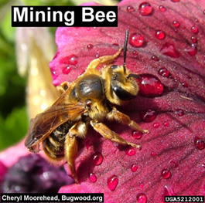 | 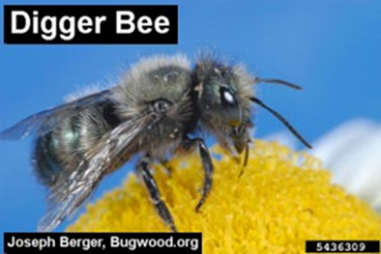

Ground nesting bees are usually solitary bees. Each female digs and provisions her own burrow. However, it's not unusual to find dozens of ground bee nests in one area if conditions are suitable for nesting. Males may fly over the burrows, patrolling for potential mates.

Ground bees generally do not present a stinging hazard, however, female ground bees can sting. A sting from the above mentioned ground bees would be a rare and minor annoyance. Ground bees are not aggressive. However, they will sting in self-defense if threatened. Males of some species may behave aggressively around nesting areas, but they lack a stinger and cannot sting. Sweat bees do have a somewhat startling habit of landing on people to lap up the perspiration from their skin. This behavior is, in fact, why they are called sweat bees. If you swat a sweat bee when it lands on you, you may receive a minor sting.

Before you decide to eliminate these ground bees, you should remember that these bees serve an important role as pollinators. They're not aggressive, and in most cases, you can still mow your lawn and continue your regular outdoor activities without fear of being stung. Also, nesting activity is limited to spring, so ground bees won't stay for long. Unless you have concerns for a family member with a bee venom allergy, it's usually preferable to leave ground bees alone.

Ground bees nest in dry soil, and avoid damp areas when choosing nest sites. The easiest and least toxic method of controlling ground bees is simply to water the area. As soon as you see ground bee activity, start soaking the area with at least an inch of water per week. This is usually enough to discourage the burrowing females, and will encourage them to relocate to drier ground. A thick layer of mulch on bare garden beds will also deter ground bees from trying to dig their burrows. Pesticides are not recommended for the control of ground bees.

Other bees and wasps also nest in the ground and may present a greater stinging hazard if their nest is located near regular human activity. Bumble bees and yellow jackets live in social colonies and usually nest in underground burrows.

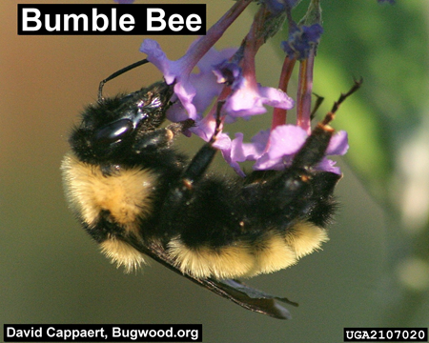 | 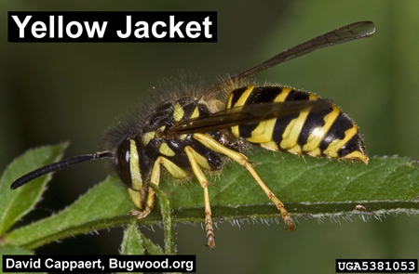

They typically use abandoned rodent burrows rather than excavate their own nesting chamber. Bumble bee and yellow jacket nests should be observed from a safe distance so as not to disturb them. If multiple bees or wasps are entering and exiting the nest entrance be aware that if disturbed, they will aggressively defend their nest. Control measures are warranted if a bumble bee or yellow jacket nest is located near regular human activity and presents a stinging hazard. Recommended control measures may be found under the Bee Control listing (page 289-290) and the Hornet, Mud Dauber, Wasp, & Yellow Jacket listing (page 297-298) in the HOUSEHOLD AND STUCTURAL PEST CONTROL Section of the current MP144 “Insecticide Recommendation for Arkansas” (https://www.uaex.edu/publications/pdf/mp144/m-household-pests.pdf).

Grasshoppers
Kelly M. Loftin

Over the last few weeks, I have received a few calls about small grasshoppers in pastures and hayfields. So far I’m unaware of any significant grasshopper damage. Historically, we seem to have the worst grasshopper issues during dry/hot weather especially when forage is in short supply. Naturally occurring grasshopper fungal pathogens that help lower abundance can be suppressed in hot and dry drought conditions.

Grasshoppers can consume up to 50% of their body weight in forage each day. In contrast, cattle consume up to about 2.5% of their body weight in forage per day. In other words, 50 pounds of grasshoppers would eat about as much as a full grown cow. To make matters worse, grasshoppers compete directly with livestock because they preferentially feed on the most desirable forage plants.

Several species of grasshoppers occur in Arkansas. Some of the most common grasshopper species include the red-legged, differential, two-striped, and lubber.

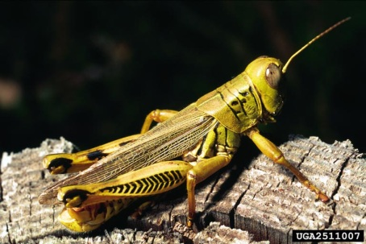 | 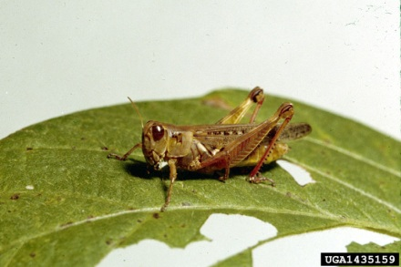 | 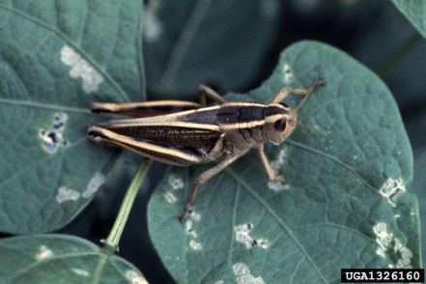
Differential grasshopper. Photo by David Riley, Univ. of Ga., Bugwood.org. | Red-legged grasshopper. Photo by Clemson Univ., Bugwood.org. | Two-striped grasshopper. Photo by Whitney Cranshaw, Colorado State Univ., Bugwood.org.

Grasshoppers are difficult to control particularly the large ones. In addition, grasshoppers will fly a considerable distance in search for suitable food. In some situations, insecticide application can be a viable option. However, it can be difficult to judge whether control is economically warranted. Before treating a pasture or hayfield for grasshoppers, producers should weigh the value of the field as hay or forage against the cost of an insecticide application. In general, a broadcast insecticide application is not economically feasible if less than 10 grasshoppers per square yard are found. Another option to consider is spot treating areas where a large number of grasshopper nymphs are observed. This technique can reduce grasshopper numbers in local areas because newly hatched nymphs remain concentrated in the hatching areas for some time. Later on, as wings develop, grasshoppers are capable of flying from the hatching area in search of suitable forage.

Two of the most important factors to consider when choosing an insecticide to apply to a pasture are the size of the grasshopper and grazing restriction. If the grasshoppers are larger than ½ inch, they are more likely to survive treatment with an IGR product (such as Dimilin®). In addition, if grasshoppers are large, the higher rate of conventional products such as carbaryl or the pyrethroids are recommended. Products containing chlorantraniliprole/lambda-cyhalothrin (Besiege®) and chlorantraniliprole (Prevathon®) provide longer residual control. Grazing restrictions vary with product. For example, carbaryl cannot be applied within 14 days of harvest or grazing. In contrast, lambda-cyhalothrin, beta-cyfluthrin, chlorantraniliprole and chlorantraniliprole/lambda-cyhalothrin have a 0 day grazing restriction when applied to grass. See the pasture section of the 2017 MP 144 “Insecticide Recommendations for Arkansas” (https://www.uaex.edu/publications/pdf/mp144/c-forages.pdf) for product names, rates and grazing/harvest restrictions.

Fall Armyworm Demonstration Update
Steven Stone, Hank Chaney, Gus Lorenz, and Kelly Loftin

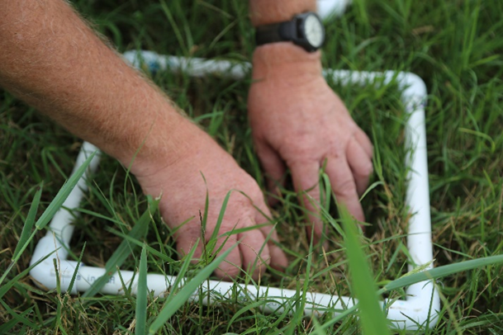
Counting fall armyworms at Star City fall armyworm demonstration. Photo by Mary Hightower.
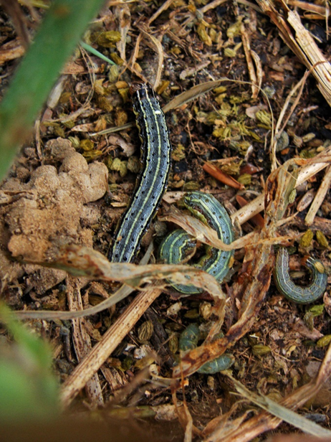
Mixed-sized fall armyworms in Star City untreated plot. Photo by Mary Hightower.
Fall armyworms made an early appearance in Arkansas bermudagrass this year and we are currently seeing another round of significant infestations. We may end up battling these worms for several more weeks. Fall armyworms

started off in mid-June at populations well above treatment threshold and with mixed worm sizes, indicating overlapping generations. With overlapping generations, frequently reinfestation is common and may result in significant yield losses or the need to make multiple insecticide applications. Last year some of our producers had to make three and rarely four insecticide applications to make their hay crop. Pyrethroids, such as lambda-cyhalothrin, are effective and frequently used to control fall armyworms in pastures and hay fields. Their lower per-acre cost is desirable, but unfortunately, they provide very little residual activity. To show product differences, we conducted demonstrations to compare the residual activity of the widely used pyrethroid insecticide - lambda-cyhalothrin and the insecticide Besiege® that contains chlorantraniliprole plus lambda-cyhalothrin. A brief summary of the evaluation is provided below.

Demonstration Summary
Application date: July 7, 2017
Demonstration area: 6 acres (2 acres per treatment)
Crop: Bermudagrass pasture
Treatments:
Untreated Control
Besiege® – 6.0 oz. product per acre
Generic lambda-cyhalothrin – 3.2 oz. product per acre

 | Average # of fall armyworms per square foot.
Treatment | Pre-treat | 3 DAT* | 7 DAT | 17 DAT | 21 DAT
Untreated Control | 5.0 | 3.6 | 1.2 | 8.3 | 8.9
Besiege® | 10.4 | 0.0 | 0.0 | 0.9 | 0.1
Generic lambda-cyhalothrin | 6.6 | 0.0 | 0.0 | 8.7 | 13.0
On the 14 DAT evaluation numerous newly hatched fall armyworm larvae were present in all experimental plots.
*DAT = days after treatment.

Results demonstrated that both treatments – Besiege® and generic lambda-cyhalothrin - provided excellent initial control. However, the chlorantraniliprole/lambda-cyhalothrin combination product was the only treatment to provide 21 days of effective control. In this specific case, one spray application would have been eliminated by using a product with long residual activity. When choosing a treatment option to control fall armyworms in pasture, always consider the product cost per acre, the labor and fuel cost per acre, grazing and/or harvest restrictions and maturity of the hay crop. The cost in labor and fuel (estimated at ~$5.00/A) is often overlooked when choosing treatment options. Stay tuned - additional evaluations will be made at 28 and 35 DAT.

Controlling Wildlife with Poisons & Fumigants – Don’t Do It!
Becky McPeake

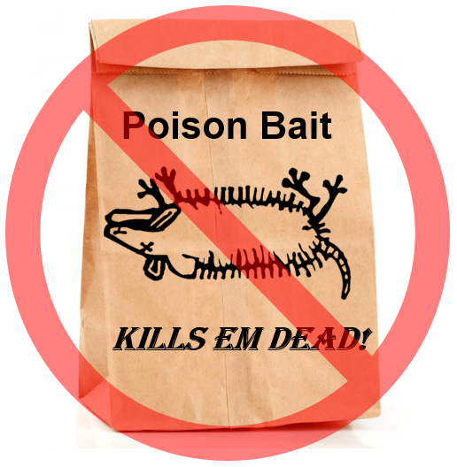
Do you know it is illegal to use toxicants on wildlife in Arkansas? This little known regulation prohibits the use of poisons or fumigants on any wildlife in the state with the exception of mice and rats. Toxic products affecting wildlife may be available for purchase in stores, but are illegal to use. The Arkansas State Plant Board, which approves such products for commercial distribution in the state, indicates that Arkansas Game and Fish Commission regulations supersede regulations issued by other agencies regarding use of these products.

This law is in place for several reasons, primarily to reduce the incidence of sickness or death of non-target animals. There have been reported instances of pets or protected wildlife ingesting poisons directly or indirectly when ingesting a poisoned animal.

When encountering nuisance wildlife, consider these options:

- Depending on the particular wildlife species, non-lethal options may work. These include frightening with shiny or new objects, sounds, or using repellents. However, often these are of limited effectiveness as wildlife easily become habituated. Hungry wildlife may eat plants with repellents applied, for example when populations are high and food is scarce.

- Live trapping and relocating nuisance raccoons, opossums, skunks, squirrels, and armadillos is allowed. It is not legal to trap other species such as deer, bears, endangered species, and migratory birds.

- English sparrows, blackbirds, starlings and crows committing damage to agriculture crops and personal property may be taken without a permit.

- In areas where the discharge of firearms or trapping is allowed, beaver, coyote, muskrat, nutria, opossum, raccoon, squirrel, striped skunk and nongame wildlife such as armadillo, gophers and moles (excluding migratory birds and endangered species) that are causing damage to personal property may be taken during daylight hours or trapped the entire year. As a precaution, consider taking a photo of damage caused by a game animal and discuss your intended actions with your wildlife officer to be sure you are in compliance.

- A depredation permit is required for night-time shooting of any wildlife. Contact a regional office with the Arkansas Game and Fish Commission to obtain a permit when nuisance wildlife are an issue.

If in doubt about a particular control method, contact your local wildlife officer, or call the Arkansas Game and Fish Commission at 1-800-364-4263.

Pepper and Tomato Fruit Anthracnose
Sherrie E. Smith

Anthracnose of pepper and tomato occurs wherever they are grown. It is caused by several species of Colletotrichum, including C. gloeosporioides, teleomorph Glomerella cingulata, C. capsici, C. coccodes, and perhaps others. Ripening fruit is the most susceptible, but the disease can occur on fruit, leaves, and stems any time conditions are right for disease development. Lesions on the fruit are circular, and may reach a diameter of more than one inch. The center of the lesion will have tan to orange to black concentric rings. Salmon-colored masses of spores are often evident during extended periods of leaf wetness. The lesions on stems and leaves are irregularly shaped gray brown spots with dark brown edges. Crop rotation of at least three years and the use of pathogen free seed are the best means of control. A 30-minute hot water bath at 52°C water disinfests seed. Deep plowing of crop residue and removal of crop debris limits overwintering inoculum. Fungicides have limited usefulness under heavy inoculum pressure and wet conditions. Quilt, Reason, Maneb, Quadris, and Cabrio are labeled for control of anthracnose on peppers. Quadris Top, Riaxor, Inspire Super, and Fontelis are labeled for tomato. Homeowners may use a Garden Fungicide containing chlorothalonil.

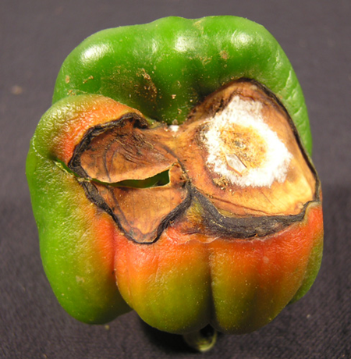 | 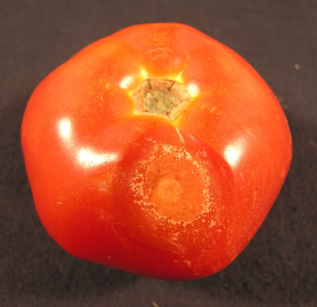
Pepper Anthracnose- Colletotrichum sp. | Tomato Anthracnose- Colletotrichum sp.

Pollinator Program
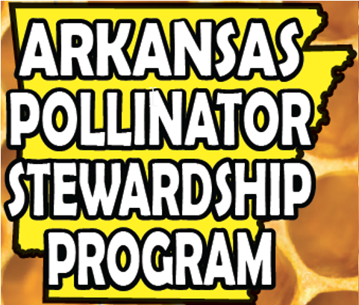
Jon Zawislak

Most County Extension Personnel are already familiar with the Arkansas Pollinator Stewardship Program but just in case you need a refresher, here is a short link to the program. www.uaex.edu/pollinators

Name That Weed
Bob Scott

This weed plagues many acres in eastern Arkansas especially along rivers on heavy soils. The new Xtend technology is an excellent option for this weed as Dicamba, both in season and in the fall, is very effective! Often large areas of this weed can be eliminated from an underground "mother plant" or series of connected plants. Be the first to email Dr. Bob Scott at bscott@uaex.edu with the correct SCIENTIFIC NAME of this weed and win a prize!

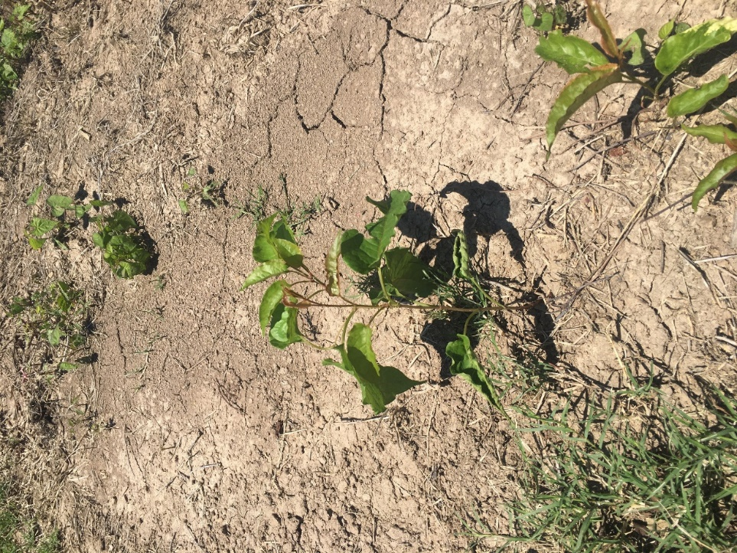

To The Readers
Please offer any suggestions for Urban or Livestock Integrated Pest Management topics (insect pests, plant diseases, weed problems, wildlife control problems) that you would like to see – OR – feel free to submit an article that you have prepared. Kelly and I will be glad to include it (subject to editing). Send feedback to jhopkins@uaex.edu or kloftin@uaex.edu.

