This bulletin from the Cooperative Extension Plant Health Clinic (Plant Disease Clinic) is an electronic update about diseases and other problems observed in our lab each month. Input from everybody interested in plants is welcome and appreciated.

 The Plant Health Clinic now has a Facebook page:
https://www.facebook.com/UAEXPlantHealthClinic/?pnref=story

Lisianthus/African violet

Sometimes a plant comes in with odd symptoms and no apparent cause. The cyclamen mite, Steneotarsonemus pallidus, is a serious pest of many ornamental plants, including cyclamen, African violet, begonia, gerbera, ivy, chrysanthemums, geranium, fuchsia, larkspur, petunia, snapdragon, Lisianthus, and other greenhouse grown plants. Cyclamen mites feed by piercing plant cells and sucking out the contents. Their feeding activity causes leaf streaking, cupping, puckering, thickening, and sometimes plant death. The crown may have excessive hairs on the leaves. Flowers may be streaked, twisted, or deformed. Secondary bacterial and fungal infections may occur via entry through mite feeding sites. Cyclamen mites are parthenogenetic, meaning they can reproduce asexually and one mite can become a colony. They are easily transferred plant to plant via tools, clothing, gusts of air, and close plant proximity. Control can be challenging. Isolate infested plants. Severely infested plants should be discarded. The pots should not be reused until they have been soaked for 30 minutes in a solution of 1 part household bleach to nine parts water. Neem oil, Ortho Houseplant Insect Killer, or insecticidal soap may be used. One method that has been used successfully is to submerse the plant in 110°F water for 30 minutes. For plants in the ground, commercial growers may use Avid 0.15EC, or Sirocco, or Pylon, or Akari, or Sanmite 75WP, or Judo, or sulfur.

African Violet Cyclamen Mite-Steneotarsonemus pallidus

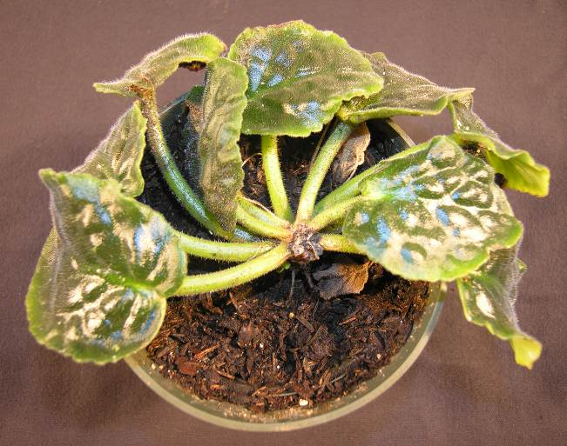
Sherrie Smith, University of Arkansas Cooperative Extension

African Violet Cyclamen Mite crown damage-Steneotarsonemus pallidus

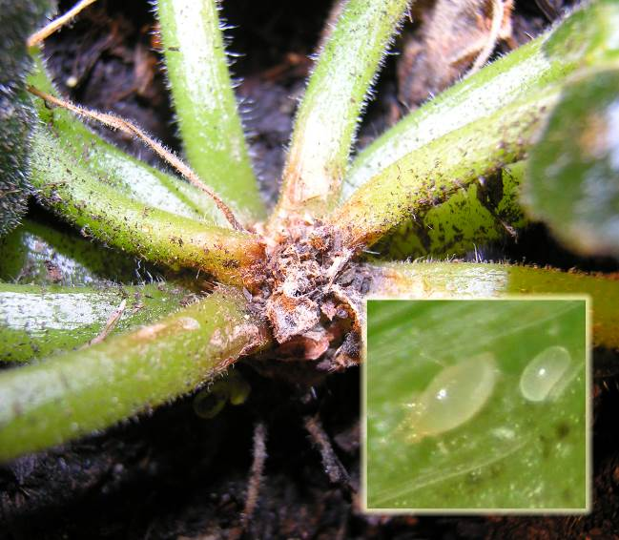
Sherrie Smith, University of Arkansas Cooperative Extension

Lisianthus Cyclamen Mite damage with secondary bacterial rot-Steneotarsonemus pallidus

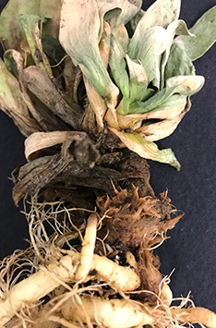
Sherrie Smith, University of Arkansas Cooperative Extension

Euonymus

Euonymus is ubiquitous in the landscape. It is one of the most widely sold evergreen landscape plants found in both commercial and home landscapes. In spite of its popularity, euonymus is prone to several insect and disease problems. Euonymus scale, Unaspis euonymi, is the most common and aggravating insect problem we see on Euonymus. Euonymus scale is such a problem that we no longer recommend Euonymus japonica to growers. Scale can also attack pachysandra, bittersweet, camellia, celastrus, ivy, hibiscus, holly, and Ligustrum. Scale insects injure plants by using their piercing sucking mouthparts to feed on sap. Sooty mold fungi often colonize leaves that have become coated with the excess amounts of sugary sap that the insects secrete. Sooty Mold fungi do not directly injure the plants, but may reduce their ability to photosynthesize. Plants heavily infested with scale grow slowly, become chlorotic and stunted. Severe infestations may cause branch dieback and plant death. Male euonymus scale are easily observed with their elongate white bodies. Females are less noticeable, although larger (over 1/16 inch long), brown, and pear-shaped. In severe infestations, leaves and stems may be heavily encrusted. There are several generations a year. Crawlers are active in May, June, and July. Plants in shady locations with poor air circulation are more at risk than those in open sunny locations. Over-fertilization and poor watering practices, either too much or too little, promote scale infestations. Heavily infested plants should be pruned back and new growth protected with insecticide treatments. Dormant oils applied during the winter months help reduce over-wintering populations. Fine horticultural oils and insecticidal soaps are options for summer control. Bayer Advanced Tree and Shrub Insect Control (Imidacloprid) is a systemic insecticide that gives good results, or Bayer Advanced Garden Power Force Multi-Insect Killer (Cyfluthrin). Spreading euonymus, (Euonymus kiautschovicus), Dwarf winged euonymus (Euonymus alatus 'Compactus'), and Winter creeper euonymus (Euonymus fortune), are more resistant to heavy attacks by this pest.

Euonymus Scale-Unaspis euonymi
Sherrie Smith University of Arkansas Cooperative Extension
Euonymus Scale-Unaspis euonymi

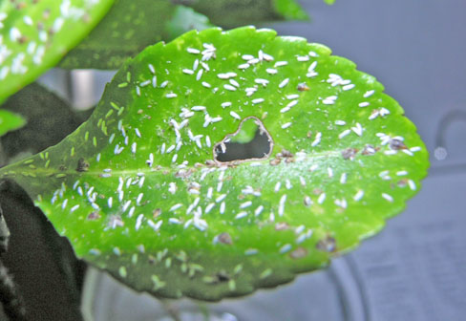
Sherrie Smith, University of Arkansas Cooperative Extension

Euonymus Scale-Unaspis euonymi

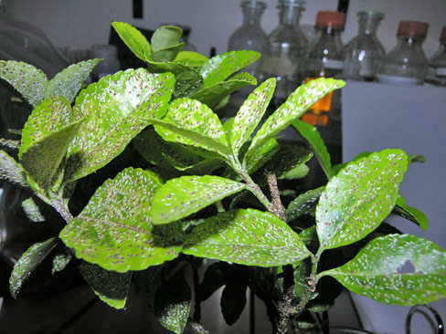

Plums and cherries
With trees not yet leafed out, some homeowners are noticing black, knobby galls on the branches of their cherries or plums. The common name of the disease is Black Knot, caused by Apiosporina morbosa (Dibotryon morbosum). This is a common fungal disease of Prunus spp. Yield losses result from extensive dieback of girdled limbs and stunting of growth beyond the knots. Trees can be severely weakened, disfigured and, in extreme cases, killed because of infection. Prunes, plums, sweet cherries, and sour cherries are all hosts for Black Knot. Rarely do we receive a peach sample with Black Knot. Wild cherries and plums serve as continuous sources of inoculum. The first symptoms are small, light brown swellings usually located at the base of the leaf petiole or on the fruit spur. These appear during the summer and first year after infection. Young knots may have an olive-green color, but later become hard, brittle and black in color. Older knots are coal-black in color and hard in texture. The knots often protrude more on one side of the affected branch. Control starts with pruning. Prune out and destroy all visible knots before new growth starts in the spring. The cuts should be made at least 6-8 inches below the lowest part of the knot. Cut out knots on large main branches and trunks with a knife or chisel, including an inch of healthy bark around the knot. Never purchase plants showing knots or abnormal swellings on the twigs and branches. All clippings should be burned, buried or otherwise removed from the property. Mancozeb, Captan, Topsin M, or fungicides containing chlorothalonil are helpful in controlling Black Knot if the cultural controls are also practiced. Apply first spray in the spring just as green tissue begins to appear. Spray again just before and after bloom. Spray at 2-week intervals until new growth stops. Lime-sulfur sprayed during the dormant season is also helpful. Wild cherries and plums within 600 feet of the orchard should be removed if possible to prevent spores blowing into the orchard and causing new infections. Some Plum cultivars are resistant to Black knot. The cultivars Stanley, Damson, Bluefree, and Shropshire are considered highly susceptible; Fellenburg, Methley, Milton, Bradshaw, and Early Italian are moderately susceptible; Formosa, Shiro, and Santa Rose are slightly susceptible; and President is considered highly resistant. In general, Japanese varieties are less susceptible than most American varieties.

Plum Black Knot- Apiosporina morbosa

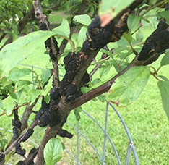
Steve Kelley, University of Arkansas Cooperative Extension

Plum Black Knot- Apiosporina morbosa

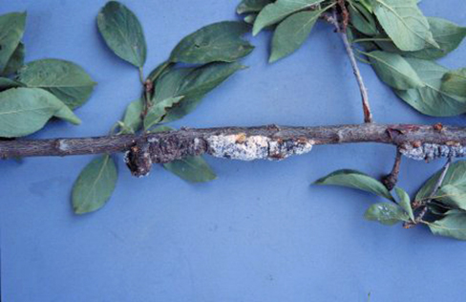
Sherrie Smith, University of Arkansas Cooperative Extension

Cherry Black Knot- Apiosporina morbosa

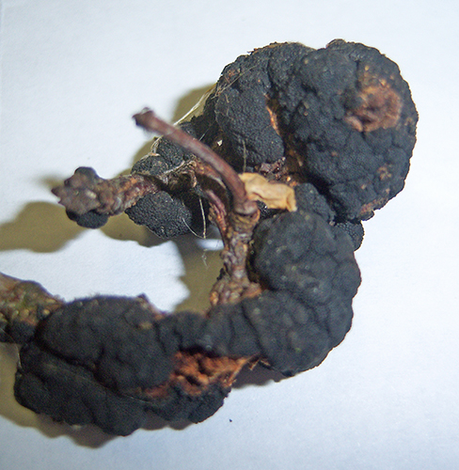
Sherrie Smith, University of Arkansas Cooperative Extension

